Supplementary material

Identification of NEK3 interacting proteins and phenotypical characterization of its silencing in HeLa cells
Vanessa Bomfim Cardoso, Talita Diniz Melo-Hanchuk, Edmárcia Elisa de Souza, Priscila Ferreira Slepicka, Gabriela Vaz Meirelles and Jörg Kobarg

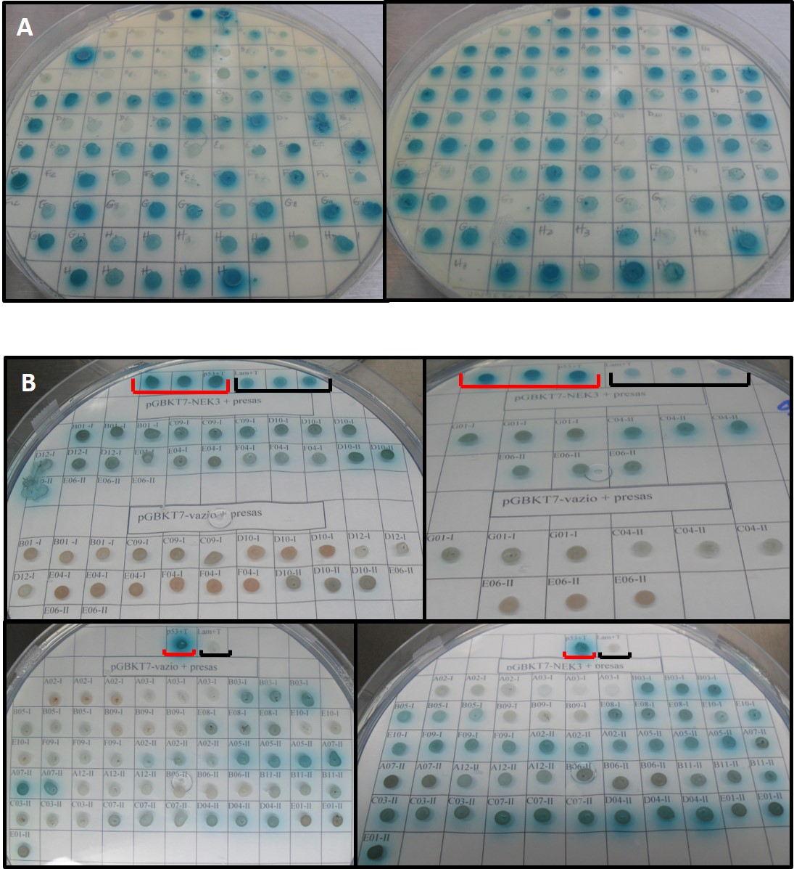
Supplementary Figure S1: NEK3 interactors in Yeast Two Hybrid Screening. A) Interaction assay in QDO-XA plates, where blue colonies represents interaction between bait (NEK3) and preys. B) Confirmation of interaction in QDO-XA plates: Positive control, Negative control, Bait and prey, Prey and empty vector.
Supplementary Table S1: NEK3 interactome after Yeast two hybrid screen: Prey proteins found in yeast two-hybrid screening, after submission to IIS platform. Clones from (named from A to H and numbered from 1-12) two colonies plates (named as 001 and 002) after analyses were united as contigs. The contigs are represented as letter “C” followed by its respective number.
Contigs | Protein ID | Biological Process (GO) | Gene ID | UNIPROT ID | Amino acid sequence retrieved/Total protein length | E-Value
C11 (002, B10+E10+D09) | Rho GDP-dissociation inhibitor 2 (Rho GDI2) | regulation of small GTPase mediated signal transduction | ARHGDIB | P52566 | 34-201/201 | 1,00E-117
C5 (001,F05)+(002,D03) | Sodium/potassium-transporting ATPase subunit beta-3 | blood coagulation | ATP1B3 | P54709 | 30-198/198 | 1,00E-127
C3 (001,C03+B01)+(002,A01+E08+B05) | Leucine-rich repeat-containing protein 6 | cilium movement | LRRC6 | Q86X45 | 117-413/466 | 1,00E-179
C8 (001,G05+C10+A12) + (002, A09+C09 ) | Sperm associated antigen 17 | cilium movement | SPAG17 | Q6Q759 | 570-660/660 | 4,00E-49
C6 (001, F08+E02+D09+D08+D05+C11+ A02) | Metaxin-2 | mitochondrial transport | MTX2 | O75431 | 4-181/263 | 1,00E-125
Singlets
001, B05 | Protein inhibitor of activated STAT 1 | androgen receptor signaling pathway | PIAS1 | O75925 | 1-271/325 | 0
001,G01 | Small nuclear ribonucleoprotein G | gene expression | SNRPG | P62308 | 28-76/76 | 3,00E-30
001,D10 | SH3-domain GRB2-like (endophilin) interacting protein 1 | positive regulation of energy homeostasis | SGIP1 | Q9BQI5 | 667-806/859 | 1,00E-44
001,D12 | Proliferation-associated protein 2G4 | cell proliferation | PA2G4 | Q9UQ80 | 204-367/394 | 2,00E-89
001,C09 | Zinc finger MYM-type protein 5 isoform 3 | transcription, DNA-templated | ZMYM5 | Q9UJ78 | 1-113/669 | 3,00E-72
001, E04 | COMM domain-containing protein 1 | copper ion homeostasis | COMMD1 | Q8N668 | 1-190/190 | 0
001,F09 | Ribosomal L24 domain containing 1 | translation | RSL24D1 | Q9UHA3 | 128-163/163 | 1,00E-11
001,B08 | SFRS2 protein | gene expression | SFRS2 | Q01130 | 144-175/179 | 5,00E-10
002,B11 | Eukaryotic translation initiation factor 4E type 3 isoform a | regulation of translation | EIF4E3 | Q8N5X7 | 131-224/224 | 1,00E-27
001, B03 | Syntaxin-8 | transport | STX8 | Q9UNK0 | 1-236/236 | 0
001, E08 | Mitotic spindle-associated MMXD complex subunit MIP18 | small molecule metabolic process | FAM96B | Q9Y3D0 | 11-163/163 | 1,00E-79
002, A12 | Fibrillin 1 | sequestering of TGFbeta in extracellular matrix | FBN1 | P35555 | 2704-2869/2869 | 7,00E-89
002, E01 | Cullin 1, isoform CRA_a | mitotic cell cycle | CUL1 | Q13616 | 531-666/666 | 1,00E-68
002, A07 | M-phase phosphoprotein, mpp8, isoform CRA_a | negative regulation of transcription, DNA-dependent | MPHOSPH8 | Q99549 | 285-544/867 | 0
001, E10 | Contactin-1 isoform 2 precursor | cell adhesion | CNTN1 | Q12860 | 811-1007/1007 | 8,00E-88
001, A03 | Zinc finger 131 protein | transcription from RNA polymerase II promoter | ZNF131 | P52739 | 382-510/510 | 3,00E-37
002, A05 | Cytidine monophosphate kinase 1 | CDP biosynthetic process | CMPK1 | P30085 | 91-228/228 | 1,00E-71
002, B08 | Translation factor sui1 homolog | translation initiation factor activity |  | Q53F41 | 1-113/113 | 7,00E-50
002, E04 | DnaJ (Hsp40) homolog, subfamily B, member 4 variant | response to unfolded protein | DNJB4 | Q9UDY4 | 260-344/344 | 3,00E-41
002, C03 | Chromosome X open reading frame 57 | Unclassified | CXorf57 | Q6NSI4 | 417-566/566 | 9,00E-83
002, B06 | Mediator of RNA polymerase II transcription subunit 17 | gene expression | MED17 | Q9NVC6 | 438-601/651 | 3,00E-68
002, B03 | ATPase, Na+/K+ transporting, beta 1 polypeptide | blood coagulation | ATP1B1 | P05026 | 159-303/303 | 3,00E-73
002, D04 | Proliferating cell nuclear antigen | cell proliferation; DNA repair | PCNA | P12004 | 147-261/261 | 7,00E-57
002, C07 | Clusterin associated protein 1, isoform CRA_a | cilium assembly;organelle organization | CLUAP1 | Q96AJ1 | 175-296/387 | 1,00E-46

