NIMA-related kinase 7 interacts with Mat1 and is involved in the UV-induced DNA Damage Response

Arina Marina Perez¹, Edmarcia Elisa de Souza¹ and *Jörg Kobarg^{1,2}.

¹Programa de Pós-graduação em Biologia Funcional e Molecular, Departamento de Bioquímica e BiologiaTecidual, Instituto de Biologia, Universidade Estadual de Campinas, Campinas, 13083-862 SP, Brazil
²Faculdade de Ciências Farmacêuticas, Universidade Estadual de Campinas, Campinas,
13083-859 SP, Brazil

* Author to whom correspondence should be addressed; E-Mail: jorgkoba@unicamp.br; Tel.: +55-19-3521-1443.

Supporting information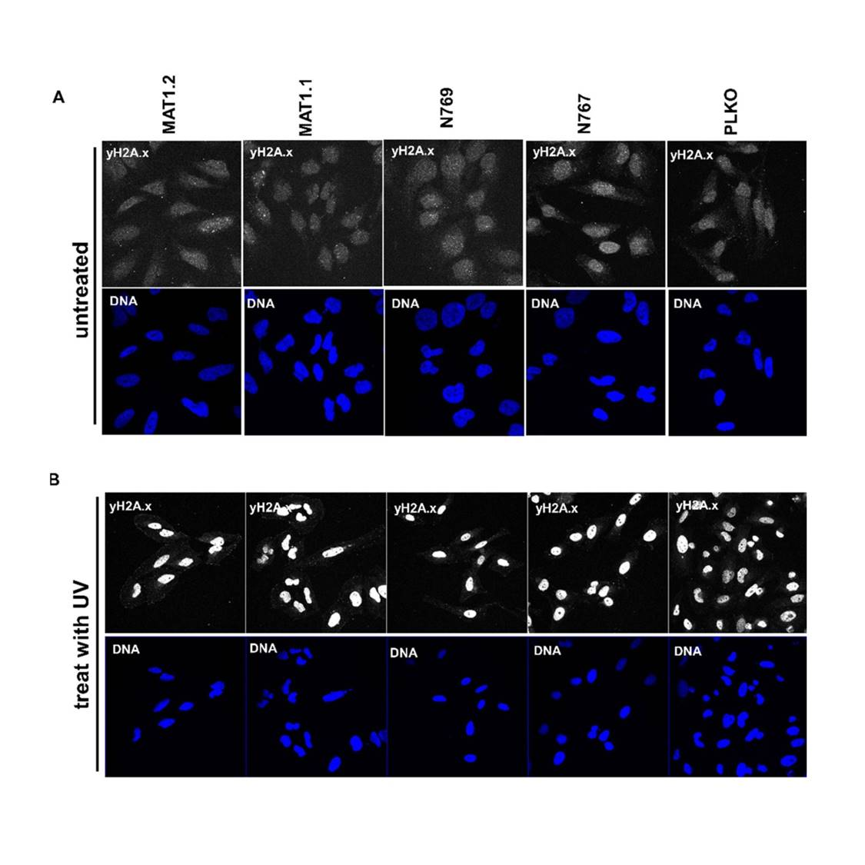
S1 Fig: Confocal microscopy immunofluorescence images of Hela cells depleted for Nek7 (two stably transfected clones named N769, N767) or Mat1 (two stably transfected clones named MAT1.1 and MAT1.2). Control transfected Hela cells (PLKO) or cells transfected as indicated on top of the figure (non-irradiated) (A) or irradiated with 50 J/m² UV-C (B) were stained by immunofluorescence confocal microscopy using anti-γH2AX antibody. Nuclei were counterstained by Hoechst.

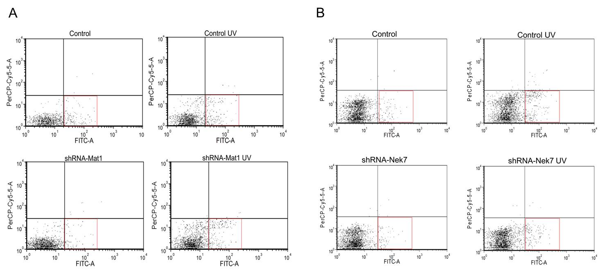
S2 Fig: Histograms used to generate graphs shown in Fig. 4 A-B: shRNA control Hela cells and cells depleted by shRNA for Nek7 or Mat1 were irradiated or not with 50 J/m² of UV light and recovered for 2 hours. After this the cells were stained with propidium iodide and annexin-FITC and analyzed by flow cytometry A) Apoptosis assay analysis by Flow cytometry of control cells (shRNA-Control) and depleted to Nek7 (shRNA-Nek7). B) Apoptosis assay analysis by Flow cytometry of control cells (shRNA-Control) and depleted to Mat1 (shRNA-Mat1). The figures were generated by the program FACS expression 4 Flow Research edition. Red squares correspond to apoptosis cells considered for the graphics generation in Fig. 4.

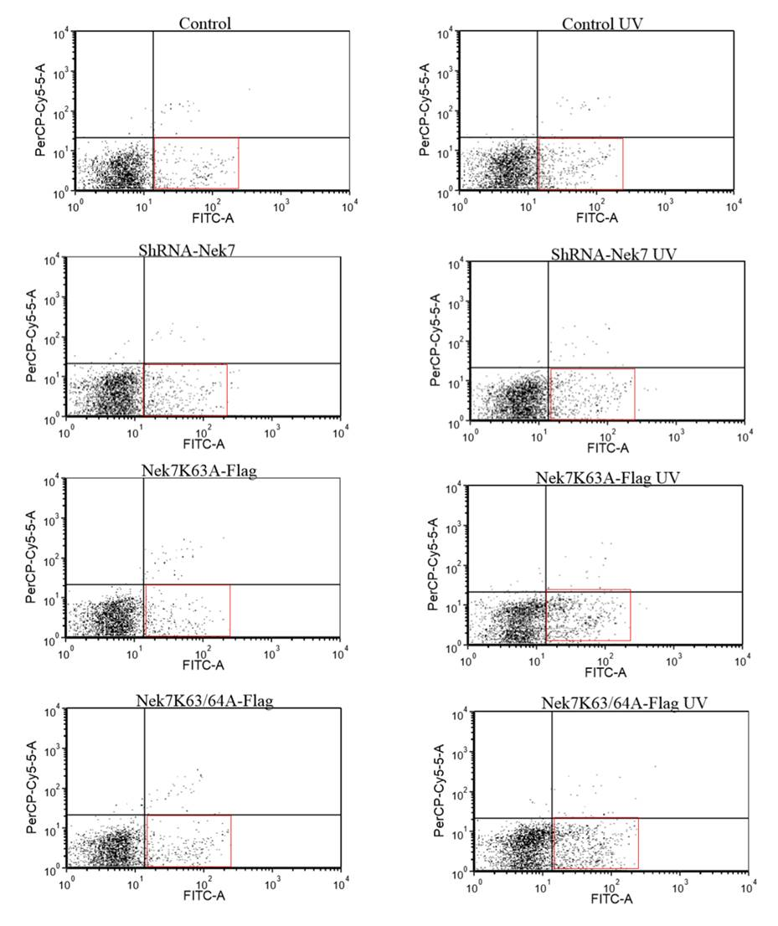

S3 Fig: Histograms used to generate the graph from Fig. 4 C: wild-type Nek7 or kinase dead -overexpressed (Nek7-K63A and Nek7-K63/64A) were irradiated or not with 50 J/m² of UV light and recovered for 2 hours. After this the cells were stained with propidium iodide and annexin-FITC and analyzed by flow cytometry. The figures were generated by the program FACS expression 4 Flow Research edition. Red squares correspond to apoptosis cells considered for the graphics generation in Fig. 4.

