Supplementary Figure 1

- ETAE_0603

Fig 1-1A, CDD of ETAE_0603 of Edwardsiella tarda EIB202 (NCBI: gi|269137961)

10 20 30 40 50 60 70 80 90 100
....|....|....|....|....|....|....|....|....|....|....|....|....|....|....|....|....|....|....|....|
Edwardsiella_tarda_EIB202 ----MTESLTPRMKKSIPTLIATLVWSALYSQHALA-SLAEQCLIGVPVYDKPLVSGDIN-SLPVHITADKSEANYPNNALFHGNVDIQQGNSTLTADKV
Enterobacteriaceae_bacterium ----MTELLKPRMKKSIPTLVATLVWSALYSQNALA-DLAEQCLLGVPMYNKPLVSGNPN-DLPVHIQADKSDANYPDNAVFSGNVNIEQGNSTLTADQV
Yersinia_ruckeri ------------MKKRFPTLLATLIWTALYSQQSLA-GLAEQCMFGVPTYDKPLVTGDTN-QLPVNIQADKTEANYPDSAVFTGNVIVEQGNSTLTANQV
Pectobacterium_wasabiae MMPLMTEHLITRMKKSFPTLLATLVWSALYSQHALA-DLAEQCMLGVPTYNRPLVTGDPN-QLPVNIQADKTEANYPNNAKFIGNVNIQQGNSIMTAEQV
Brenneria MMPLMTEHLIPRMKKSFPTLLATLIWSALYSQQTLA-DLAEQCMLGVPTYNRPLVTGDAN-DLPVNIQADKTTANYPDSALFSGNVNIEQGNSVLTAEQV
Dickeya_dadantii MTPLMTEHQIPRMKKSFPTLLASLIGSALYSQHALA-DLASQCMSGVPVYNRPLVTGDTS-QLPVHIRADQSQANYPDSALFTGNVNVEQGNRVLTADQV
Sodalis_glossinidius ------------MKKRLPTLLASLIGSALYSQQALA-DLADQCLLGVPAYTKPLVSGDAN-SLPVHIQADKAAANYPEHALFSGNVYIEQGNSTLTADEV
Pantoea MMPVFMELSKPRMKKRIPTLLATMIGAAIYSQHSLADDLMSQCMLGVPSFNRPLVNGDTN-SLPVTIHSDSLKGTYPSDAVYTGNVDVQQGNSRMTADEV
Erwinia_billingiae ------------MKKRLPTLLATLIGTAIYSQQGLADDLASQCMLGVPSYNRPLVQGKTNNDLPVTINADNAKGNYPDNAVFTGNVDIQQGNSRLLSDEV
Escherichia_coli ------------MKKRIPTLLATMIATALYSQQGLAADLASQCMLGVPSYDRPLVQGDTN-DLPVTINADHAKGDYPDDAVFTGSVDIMQGNSRLQADEV
Shigella_sonnei ------------MKKRIPTLLATMIATALYSQQGLAADLASQCMLGVPSYDRPLVQGDTN-DLPVTINADHAKGDYPDDAVFTGSVDIMQGNSRLQADEV
Salmonella_enterica ------------MKKRIPTLLATMIASALYSHQGLAADLASQCMLGVPSYDRPLVKGDTN-DLPVTINADNAKGNYPDDAVFTGNVDIMQGNSRLQADEV
Cronobacter_turicensis ---MMMEPRITRMKKRIPTLLATMIGTALYSQQGMAADLASQCKLGIPTYNRPLVQGDTN-QLPVTINADHAKGNYPDNAVFTGNVDIQQGNGRLQADEV
Enterobacter_cloacae ------------MKKRIPTLLATMIASALYSQQGAAADLASQCMLGVPTYNRPLVQGDTN-SLPVTINADHAKGNYPDNAVFTGNVDVNQGNSRLQADEV
Clustal Consensus *** :***:*::: :*:**:: * .* .** *:* : :*** *. . .*** * :* . **. * : *.* : *** : :::*

110 120 130 140 150 160 170 180 190 200
....|....|....|....|....|....|....|....|....|....|....|....|....|....|....|....|....|....|....|....|
Edwardsiella_tarda_EIB202 QLDQKAIQGHP-DPLRTVTAIGNVHYADSQIRLQGPSAWSNLNNKDTNVWRGDYQFVGRQGRGDADLMKTRDANRYTILDNGTFTSCLPGDNSWSIAGSE
Enterobacteriaceae_bacterium QLDQKFLKDKP-DPLRTVTATGNVNYSDNQVKLKGPNAWSNLNNKDTNVWQGDYQFVGRQGRGTADLMKTRAENRYTILENGTFTSCLPGDNSWSVAGSE
Yersinia_ruckeri QLHQTQESGQP-VPVRTVTAIGDVNYDDPQIILKGPKAWSNLNTKDTNMDKGNYQMVGRQGRGDADLMKQRGQNRYTILENGTFTSCLPGDNSWSVVGSE
Pectobacterium_wasabiae ELNQLDPATQSSIPTRTITATGNVHYDDNQVILKGPKAWANLNTKDTDVYEGDYQMVGRQGRGSADKMKMRDSNRYTILENGSFTSCLPGDNSWSVVGSE
Brenneria ELNQIASAAQDGAPTRTITATGNVRYDDNQVVLQGPKAWSNLNTKDTDVYEGDYQMVGRQGRGSADKMKMRDDNRYTILENGTFTSCLPGDNSWSVVGSE
Dickeya_dadantii QLHQKQQAGQA-DPVRTVTAIGNVHYDDDQVILKGPRAWSNLNTKDTDVEDGDYQMVGRQGRGDADKMKQRENNRYTILDHGSFTSCLPGDDSWSVVGSE
Sodalis_glossinidius QLTQRQ--EQNNAPLRTATATGNVNYSSNEIKLQGPKAWSNLNTKDTDVYQGNYQIVGRQGRGDADTMKQRGDNRYTVLENGSFTSCLPGDDSWSVVGSE
Pantoea QLHQRQQEGQT-TPVRTVDALGNVHYDDNQVILKGPKAWSNLNTKDTNVWNGNYLMVGRQGRGDADQMKLRGNNRYTILENGSFTSCLPGSNSWSVVGSE
Erwinia_billingiae QLHQKQQPGQP-TPVRTVDALGNVHYDDNQVILKGPKAWSNLNTKDTNVWNGDYQMVGRQGRGTGDQMKLRGQNRYTIMENGTFTSCLPGDNSWSVAGTE
Escherichia_coli QLHQKEAPGQP-EPVRTVDALGNVHYDDNQVILKGPKGWANLNTKDTNVWEGDYQMVGRQGRGKADLMKQRGENRYTILDNGSFTSCLPGSDTWSVVGSE
Shigella_sonnei QLHQKEAPGQP-EPVRTVDALGNVHYDDNQVILKGPKGWANLNTKDTNVWEGDYQMVGRQGRGKADLMKQRGENRYTILDNGSFTSCLPGSDTWSVVGSE
Salmonella_enterica QLHQKQAEGQP-EPVRTVDALGNVHYDDNQVILKGPKGWANLNTKDTNVWEGDYQMVGRQGRGKADLMKQRGENRYTILENGSFTSCLPGSDTWSVVGSE
Cronobacter_turicensis LLHQKQAEGQP-EPVRTVDALGNVHYDDNQVILKGPKAWANLNTKDTNVWEGDYQMVGRQGRGKADLMKQRGENRYTILENGSFTSCLPGSDTWSVVGSE
Enterobacter_cloacae QLHQKEAPGQA-TPVRTVDALGNVHYDDNQVILTGPKAWSNLNTKDTNVWKGDYQMVGRQGRGTADLMKQRGDNRYTILDNGTFTSCLPGANTWSVVGSE
Clustal Consensus * * : * ** * *:*.* . :: * ** .*:***.***:: *:* :******* .* ** * ****::::*:******* ::**:.*:*

210 220 230 240 250 260 270 280 290 300
....|....|....|....|....|....|....|....|....|....|....|....|....|....|....|....|....|....|....|....|
Edwardsiella_tarda_EIB202 IIQDRQEQVAEIWNARFKIGPVPVFYSPYLQFPTGSTRRSGFLIPTINYSNGDGIEFTLPWYWNIAPQADATFTPHYMEKRG-LQLQNEFRYLSEFGMGL
Enterobacteriaceae_bacterium IIQDRQEEVAEIWNARFKIGPVPVFYSPYLQLPLGDKRRSGFLIPDFKYSSTDGVEFSLPWYWNIAPQVDATITPHYMENRG-LQLQNEFRYLTVAGSGL
Yersinia_ruckeri VIHDREEEVAEIWNARFKIGPVPIFYSPYMQLPVGNKRRSGFLIPNARYSTNTGLEFFLPYYWNIAPNFDATITPHYMEKRG-TQLQNEFRYLLAPGSGT
Pectobacterium_wasabiae VIQDREEQVAEIWNARFKIGGVPVFYSPYLQLPIGDKRRSGFLIPNAKYGSSNGFELLTPYYWNIAPNFDATITPHLQTKRG-MQWQNEFRYLATPGLGV
Brenneria VIQDREEQVAEIWNARFMIGGVPVFYSPYLQLPIGDKRRSGFLIPNAKFGSSNGFELLTPYYWNIAPNFDATITPHLQTKRG-MQWQNEFRYLTAPGAGT
Dickeya_dadantii VIQDRQEEVAEIWNARFRIAGVPVFYSPYMQLPIGNKRRSGFLIPNAKYGRNNGFELVTPYYWNIAPNYDATITPHVQTNRG-MQWQNEFRYLSRAGLGL
Sodalis_glossinidius VIHDREEQVAEIWNARFKIGKVPVFYSPYLQIPVGDKRRSGFLIPNAKYGSNNGFEFSAPYYLNLAPNYDATIMPNYMSKRG-TQIQTEFRYHTTPGEGL
Pantoea VIQDRQEEVAEIWNARFKLGNVPVFYSPYLQLPIGDRRRSGFLIPNAKYSSTNGFEFMLPYYWNIAPQADATITPHYMSNRG-LQLQNEFRYLTQFGSGL
Erwinia_billingiae IIQDREEQVAEIWNARFRIGSVPVLYSPYLQLPLGDRRRSGFLIPNAKYGSSNGFEFILPYYWNIAPQADATITPHYMSNRG-LQLQNEFRYLTLAGAGL
Escherichia_coli IIHDREEQVAEIWNARFKVGPVPIFYSPYLQLPVGDKRRSGFLIPNAKYTTTNYFEFYLPYYWNIAPNMDATITPHYMHRRGNIMWENEFRYLSQAGAGL
Shigella_sonnei IIHDREEQVAEIWNARFKVGPVPIFYSPYLQLPVGDKRRSGFLIPNAKYTTTNYFEFYLPYYWNIAPNMDATITPHYMHRRGNIMWENEFRYLSQAGAGL
Salmonella_enterica VIHDREEQVAEIWNARFKVGPVPIFYSPYLQLPVGDKRRSGFLIPNAKYTTKNYFEFYLPYYWNIAPNMDATITPHYMHRRGNIMWENEFRYLTQAGAGL
Cronobacter_turicensis VIHDREEQVAEIWNARFKLGPVPVFYSPYLQLPVGDKRRSGFLIPNAQYSKTNYFEFSLPYYWNIAPNFDATITPHYMHKRGNVQWQNEFRYLTQAGMGL
Enterobacter_cloacae VIQDRQEQVAEIWNARFKIGPIPVFYSPYLQLPIGDKRRSGFLIPNAKYGSTNGVEFYLPYYWNIAPNFDATITPHYMDKRGGIMWENEFRYLTQAGTGL
Clustal Consensus :*:**:*:********* :. :*::****:*:* *. ******** .: .*: *:* *:**: ***: *: .** :.**** * *

310 320 330 340 350 360 370 380 390 400
....|....|....|....|....|....|....|....|....|....|....|....|....|....|....|....|....|....|....|....|
Edwardsiella_tarda_EIB202 VEFDWLGNDRQFQQDRQNQGITGQALDDLKNRDRWLFYWRHFGVLDH-WRFGVDYTKVSDPYYFTDLNSAYGSSTSGYATQKFTLGYAETNWNATLSTTQ
Enterobacteriaceae_bacterium MELDWLNQDKQYADDRLNKNNISDAENDKK---RWLFYWQHSGVMDQVWRFNVDYTKVSDPYYFNDLDSTHGSSTDGYATQKFSLGYAEQNWNATLSTTQ
Yersinia_ruckeri MALDWLPSDREYKS-------LDPVNNDKA---RWLYYWGHSGVMDQVWRFNIDYTKVSDPRYFSDFTSLYGSSTDGYATQIFSVGYAQENWNATLASKQ
Pectobacterium_wasabiae IQFDWLPSDREYAKSAPQ-------DDNDT---RWLLHWGHSGVMDQVWRFNADYTKVSDDRYFTDLDSHYGSTTDGYVTQKFSAGYANQNWNTTLSTKQ
Brenneria IQFDWLPSDDEYAKDAPL-------DDNDT---RWLFHWRHNGVMDQVWRFNSDYTKVSDDRYFTDLDSEYGSTTDGYVSQKLSVGYANQNWDTTLSTKQ
Dickeya_dadantii VEFDWLPDDRQYKSDILSGKSGYASDDNYT---RWLFHWQHFGVMDQVWRFSADYTKVSDPNYFTDLDSFYGNTTDGYATQKFSLGYANQNWDATVSTRQ
Sodalis_glossinidius VEFDWLPKDRVYSSEHAS-------DGDSD---RWLLYWRHNGVMDQVWRFNVDYTKVSDSNYFDDLDSKYGSTTDGYATQKFSFGYADENWDTALSYKQ
Pantoea MELDFLPSDNQYDKDKAV--RSISQDASSD---RWLFYWRHAGVYDQHWRFNADYTKVSDPYYFNDLTSKYYSSTDGYATQKFSVGYSDTNWDATLSTKD
Erwinia_billingiae MEFDYLNSDNQFEKDAPS--RNISDDDSK----RWMFYWKHAGVYDKNWRFNVDYTKVSDTYYFTDLDSPYANSTDGYVTQKFSIGYAEKNWDATLSTKQ
Escherichia_coli MELDYLPSDKVYEDEHP-------NDDSSR---RWLFYWNHSGVMDQVWRFNVDYTKVSDPSYFNDFDNKYGSSTDGYATQKFSVGYAVQNFNATVSTKQ
Shigella_sonnei MELDYLPSDKVYEDEHP-------NDDSSR---RWLFYWQHSGVMDQVWRFNVDYTKVSDPSYFNDFDNKYGSSTDGYATQKFSVGYAVQNFNATVSTKQ
Salmonella_enterica MELDYLPSDKVYEDEHP-------KEGDKH---RWLFYWQHSGVMDQVWRFNVDYTKVSDSSYFNDFDSKYGSSTDGYATQKFSVGYAVQNFDATVSTKQ
Cronobacter_turicensis MEFDYLPSDNVYQDENP-------GMSDKH---RWLFYWQHGGVMDQVWRFNVNYTKVSDTSYFNDFNSKYGSSTDGYARQFFSVGYAVENFDATLSTLQ
Enterobacter_cloacae FEFDYLPSDKVYEDEHP-------EDDNSR---RWMFYWRHFGVMDQVWRFNVDYTKVSDANYFNDFSSKYGSSTDGYATQKFSAGYFIDNFDATVSSKQ
Clustal Consensus . :*:* .* : . . **: :* * ** *: ***. :****** ** *: . : .:*.**. * :: ** *:::::: :

410 420 430 440 450 460 470 480 490 500
....|....|....|....|....|....|....|....|....|....|....|....|....|....|....|....|....|....|....|....|
Edwardsiella_tarda_EIB202 FQVFANAGDVNAYRTAPQLDLNYYKNDLGPFDFTLYGQAVKFTNDNVYLPEADRYHVEPVLSLPLSNRWGSINTEAKLMATHYQQDVP-----------T
Enterobacteriaceae_bacterium FQVFADAGNSNSYRAEPQLDLNYYKNDIGPFDLHMYGQAVKFTNESDNQPEADRYHFEPTIDLPWSNGWASVNTETKLLATHYQQTVPDSYY------TT
Yersinia_ruckeri FQVFTDAGNANAYRAQPQLDLNYYKNDIGPFDLHVYGQVAKFTSVNPNNPKADRYHIEPALNLPLANGWASINTEAKLLATHYQQDIPTGFANSYAAANK
Pectobacterium_wasabiae FQVFSNATSRDVYRAEPQLDINYYQNDIGPVDMHLYGQAVKFTNVNDNRPEATRLHVEPALNLPLANRWASLNTEAKLLATHYQQDNLERYRTSSTPNID
Brenneria FQVFSTANSRDVYRAEPQLDINYYQNDIGPVDLHLYGQAVKFTNVNDNRPEATRLHIAPALSLPLTNRWGSLNTEAKLLATHYQQDNLDRYR--ADPTVS
Dickeya_dadantii YQIFSNLASRDIYRALPQLDMNYYQNDIGPFDLHLYGQAVKFTNVNPSLPDATRLHFEPTISMPVSNQWASLNTEAKLMATHYQQENLDAYN-------A
Sodalis_glossinidius FQVFDTNSS-DAYRTAPQLDVTYYKNDVGPFDFKVFSQAAKFTNVNNSYPEATRLHIEPTLNLPLANRWGSLNTEAKLMATHYQQENIDEYN------EN
Pantoea FQVFGTTSSSNVYRAMPQLDLNFYQNDIGPFDGRIYAQAVKFTNVNSEMPEATRLHFEPTLDLPLSNGWASLDTEAKLLATHYQQDGLDYYNGLSE---S
Erwinia_billingiae FQIFSTNASNDVYRAEPQFDYNYYQNNVGPFDTHLYAQAVKFTNVNEELPDATRLHLEPTINLPLSNGWGSLNTEAKLLATHYQQDDIEYYNNTVD---T
Escherichia_coli FQVFSEQNTS-SYSAEPQLDVNYYQNDVGPFDTRIYGQAVHFVNTRDDMPEATRVHLEPTINLPLSNNWGSINTEAKLLATHYQQTNLDWY--------N
Shigella_sonnei FQVFSEQNTS-SYSAEPQLDVNYYQNDVGPFDTRIYGQAVHFVNTRDDMPEATRVHLEPTINLPLSNNWGSINTEAKLLATHYQQTNLDWY--------N
Salmonella_enterica FQVFNDQNTS-SYSAEPQLDVNYYHNDLGPFDTRIYGQAVHFVNTKDNMPEATRVHLEPTISLPLSNRWGSLNTEAKLMATHYQQTNLDWY--------N
Cronobacter_turicensis FQVFDTSRGD-SYRAEPQLDVNFYQNDVGPFDTRLYAQAVHFTNVNENLPEATRLHLEPTISLPVSNDWGSLNAEAKLLATHYQQDNLDRYRAYRG--GN
Enterobacter_cloacae FQVFDRENSN-SYAAQPQLDVNYYYNDLGPFDAHVYGQAVKFENTNNNLPQATRLHLEPTLALPLSNGWGSLNTEVKLLATHYQQSNLDEYRTYAKNQYN
Clustal Consensus :*:* * : **:* .:* *::**.* ::.*..:* . *.* * *. *.: :* :* *.*:::*.**:******

510 520 530 540 550 560 570 580 590 600
....|....|....|....|....|....|....|....|....|....|....|....|....|....|....|....|....|....|....|....|
Edwardsiella_tarda_EIB202 QGNL----------TQLKDNVNRVMPEFKIDGKMVFERDATLL-NGYTQTLEPRAQYLYIPYRNQSDIYSYDSTLLQTDYTGLFRDRSYSGLDRIASANQ
Enterobacteriaceae_bacterium NRSA----------AHLADSVNRVMPEFKVDSKVTFDRDMDWA-QGYTQTLEPRAQYLYIPYRDQSDIGVYDSTLLQMDYTGLFRDRIYSGLDRIASANQ
Yersinia_ruckeri GNQA----------PALKDSVNRVIPQFKIDGKMVFDRQMDWA-ENYTQTLEPRAQYLYVPYRNQDDIYLYDTTLLQTDYSGLFRDRTYSGLDRIASANQ
Pectobacterium_wasabiae QSTK----------DALKDSVNRVMPQYKVDGKMVFEREMDWS-QAYTQTLEPRAQYLYVPYRDQSSIHSYDSTLMQTDYSGLFRDRSYSGLDRIASANQ
Brenneria DSSK----------NNLKDRVNRVMPQYKIDGKMVFEREMDWS-QGYTQTLEPRAQYLYVPYRNQSDIHTYDSTLLQADYSGLFRDRSYSGLDRIASANQ
Dickeya_dadantii SNPD----------SPLKSSVNRVMPQFKTDGKMVFERDMDWA-KGYTQTLEPRVQYLYVPYRNQSDIRAYDSTLLQADYAGLFRDRTFSGLDRIASANQ
Sodalis_glossinidius TGTG----------RHLKGSVNRVLPQFKTDGKMVFERDMDYA-PDYTQTLEPRLQYLYVPYRNQNDIGVYDSTILQTDYSGLFRDRTYSGLDRISSANQ
Pantoea QRTSS---------GVLKGSVNRTLPQFKMDGRLVFDRDMDWA-EGYTQTLEPRVQYLYIPYRDQSAIYPYDSTLLQTDYTGLFRDRTYSGLDRIASANQ
Erwinia_billingiae NKVN-----------QLKSSVNRVMPQFKVDGKMVFDRDMDWS-EGYTQTLEPRMQYLYLPYRDQSDIRAYDSTLLQSDYTGLFRDRTYSGLDRIASANQ
Escherichia_coli SRNT----------TKLDESVNRVMPQFKVDGKMVFERDMEMLAPGYTQTLEPRAQYLYVPYRDQSDIYNYDSSLLQSDYSGLFRDRTYGGLDRIASANQ
Shigella_sonnei SRNT----------TKLDESVNRVMPQFKVDGKMVFERDMEMLAPGYTQTLEPRAQYLYVPYRDQSDIYNYDSSLLQSDYSGLFRDRTYGGLDRIASANQ
Salmonella_enterica ANNS----------KKLEDSVNRVMPQFKVDGKLVFERDMAMLAPGYTQTLEPRVQYLYVPYRDQSGIYNYDSSLLQSDYNGLFRDRTYGGLDRIASANQ
Cronobacter_turicensis NEAA----------NNLEDSVNRVLPQFKLDGKVVFERDAGLIGDGFTQTLEPRAQYLYVPYRDQSSINNYDSSLLQSDYSGLFRDRTYGGLDRIASANQ
Enterobacter_cloacae SNPSSDNARYLNAANSLEDSVSRVLPQFKIDGKMVFERDMDWS-QGYTQTLEPRVQYLYVPYKDQSNIGVYDSTLLQSDYSGLFRDRTYSGLDRIASANQ
Clustal Consensus * *.*.:*::* *.::.*:*: :******* ****:**::*. * **::::* ** ****** :.*****:****

610 620 630 640 650 660 670 680 690 700
....|....|....|....|....|....|....|....|....|....|....|....|....|....|....|....|....|....|....|....|
Edwardsiella_tarda_EIB202 VTTGLTTRLYDDEQNERFNASIGQIYYFSPSRTGDET---TNIDRHDNTGSLVWAGDSYLKLTDNWGLRGGLQYDTRLNSVALGNAVMEYRKDAESVLQL
Enterobacteriaceae_bacterium MSTGLTTRIYDDALVERFNASLGQIYYFERSRTGDET---LSTDKDKDTGSLVWAGDSYWKITDHWGIRGGLQYDTRLNSVALGDAIMEYRKDAETMIQL
Yersinia_ruckeri IATGLTSRIYDDALVERFNVSLGQIYYFSRSRTGDENKNQTNIDNSDDTGSLVWAGDTYWKITDKWGLRGGAQYDTRLGSLTQGNTVMEYRHNAETVFQL
Pectobacterium_wasabiae LVTGVTTRIYDDALVERFNASIGQIYYFDRPRTGDRS---TSLDKSDNNGSQVWAGDSFLKINDSWGVRGGLQYDNRLNEVALGDAVLEYRRDAERLVQL
Brenneria LATGVTSRIYDDELVERFNASVGQIYYFDRPRTGDGN---MSLDQSDDNGSMVWAGDAYLKVDDNWGMRGGLQYDARLNEVALGDAVLEYRKDAERLVQL
Dickeya_dadantii VSSGVTTRLYDSALEERFNASMGQIYYFDRPRTG-TN---SSLDQNDERGSLNWAGDAYWKFADNWGLRGGAQYDERLKSVTLGDAILEYRGGGERMFQL
Sodalis_glossinidius LAGGVTTRIYDDQRAERFNASVGQIYYFSRPRTGDIT---GTWDNYDNTGSVVWAGDSYWRISNQWGIRGGLQYDSRLNSVALGDAVLEYRRDENRILQL
Pantoea VATGVTTRIYDNDLVERFNVSVGQIYSFTPSRTGVQQ---IDDE--DDTGSLIWAGDTYWKVSDRWGVRGGLQYDTRLDNVAQGNAVLEYRQDADRMVQL
Erwinia_billingiae VTSGVTTRIFDNDLVERFNASVGQIYSFTPSRTGLEN---ADS---DDRGSLVWAGDTYYRISDRWSTRGGLQYDTRLDNVSQGNAVLEYRRDADRMVQL
Escherichia_coli VTTGVTSRIYDDAAVERFNISVGQIYYFTESRTGDDN---ITWENDDKTGSLVWAGDTYWRISERWGLRGGIQYDTRLDNVATSNSSIEYRRDEDRLVQL
Shigella_sonnei VTTGVTSRIYDDAAVERFNISVGQIYYFTESRTGDDN---ITWENDDKTGSLVWAGDTYWRISERWGLRGGIQYDTRLDNVATSNSSIEYRRDEDRLVQL
Salmonella_enterica VTTGVTTRIYDDAAVERFNVSVGQIYYFTESRTGDDN---IKWENDDKTGSLVWAGDTYWRISERWGLRSGVQYDTRLDSVATSSSSLEYRRDQDRLVQL
Cronobacter_turicensis VTTGVTSRIYDDASVERFNVSVGQIYYFTQSRTGDDD---INWEKNKDTGSMVWAGDTYWRISDRWGLRGGVQYDARLANVATGNGVIEYRRDDDRVLQL
Enterobacter_cloacae VTTGLTTRVYDDHAVERFNVSVGQIYYFTESRTGDEN---VTWEKDDQRGSLVWAGDTYWRMTDQWGLRGGIQYDTRLDNVATASGTVEYRRDQDRLVQL
Clustal Consensus : *:*:*::*. **** *:**** * .*** .. ** ****:: :. : *. *.* *** ** .:: .. :*** . : :.**

710 720 730 740 750 760 770 780 790 800
....|....|....|....|....|....|....|....|....|....|....|....|....|....|....|....|....|....|....|....|
Edwardsiella_tarda_EIB202 SYRYASPEYITSMLPS-YANNAI-YNQGISQAGIIGSLPLADRWAMVAGYYYDTKAKQSADAIAGLQYNTCCWSVGVTYERKINSWDSATQ--NSKYDNK
Enterobacteriaceae_bacterium NYRYASPEYVTAMIPR-YASNDL-YNQGISQVGTIGSIPIADRWALVAAYYYDTNANQTADSLVGLQYNTCCWSVGVNYERKITSWDSTASQPNSKYDNK
Yersinia_ruckeri NYRYASPEYVKAALPN-INTEAPGYQNGISQVGATASLPLADRWAIVGSYYYDTKARQPASQLLGVQYNTCCWAVNLGYERKINGWNTLDN--TSKYDNK
Pectobacterium_wasabiae NYRYASPEYIRDMIPN---VTNPGFQQGISQVGITASWPIVERWAVVGAYYYDTKANQPANQLIGLQYNTCCWAVSVGYERKITDWNSASR--SSEYDNK
Brenneria NYRYASPEYIQAMLPN---VQNPGFQQGISQVGVTASWPIVDQWAVVGAYYYDTKANQPASQLIGVQYNTCCWAVSVGYERKITDWE--SN--GSVYDNK
Dickeya_dadantii NYRFASSEYIQAMLPN---ITNPGFQQGISQVGATASWPLSDRWAIVGAYYYDTKANQPADQLVGLQYNTCCWAVNVGYERKITKWNSTTN--QSVYDSK
Sodalis_glossinidius NYHYASPQYIEQMLSD---ISHTGYQQGISQVGVTGSWQLVDRWSLVGAYYYDTKANQPADQLVGLQYNTCCWAINVGYERKITGWNSTDS--SSQYDNK
Pantoea SYRYSSPEYVAQALNNSSLVTNPIYKNGISQVGATASWPIADAWSLVGAYYYDTRNSKPADQVLGLQYSSCCYAIRVGYERKINGWENNN----SKYDNQ
Erwinia_billingiae NYRYTSPEYIAQTLST---VTNPGYQDGISQVGATASWPIADAWSVVGAWYYDTKAKQPADQLLGVQYSSCCYAIRLGYERKITSWNSDNS--TSNYDNK
Escherichia_coli NYRYASPEYIQATLPKY-YSTAEQYKNGISQVGAVASWPIADRWSIVGAYYYDTNANKQADSMLGVQYSSCCYAIRVGYERKLNGWDNDKQ--HAVYDNA
Shigella_sonnei NYRYASPEYIQATLPKY-YSTAEQYKNGISQVGAVASWPIADRWSIVGAYYYDTNANKQADSMLGVQYSSCCYAIRVGYERKLNGWDNDKQ--HAVYDNA
Salmonella_enterica NYRYASPEYIQATLPSY-YSTAEQYKNGINQVGAVASWPIADRWSIVGAYYFDTNSSKPADQMLGLQYNSCCYAIRVGYERKLNGWDNDKQ--HAIYDNA
Cronobacter_turicensis NYRYASPEYIQATLPS--YSTAEQYKDGINQVGMTASWPIVDRWSVVGAYYYDTNANEAADQMLGVQYNSCCYAIRVGYERKLNGWDTDK----SKYDEV
Enterobacter_cloacae NYRYASPEYIQATLPS--YATSAQYNQGISQVGMTASWPIVDRWSVVGAYYFDTNTRKSADQMLGVQYSSCCYAIRVGYERKLNGWDTNSN--ESKYDNT
Clustal Consensus .*:::*.:*: : :::**.*.* .* : : *::*..:*:**. : *. : *:**.:**::: : ****:. *: : **.

810 820 830
....|....|....|....|....|....|...
Edwardsiella_tarda_EIB202 FSFKFALRGMNQNYSLGTAEMLRSGILPYQRAF
Enterobacteriaceae_bacterium FSFTFALRGLGTNYSLGTADMLQKGILPYQRAF
Yersinia_ruckeri ISFNVELRGLSSDHSLGTQQMLRSGILPYQSAF
Pectobacterium_wasabiae VSFNIELRGLSSNYSLGSDKMLRSGILPYQRAF
Brenneria VSFNIELRGLSNNYSLGSEKMLRSGILPYQRAF
Dickeya_dadantii IGFSFELRGLSSNYNLGTDKMLRNSILPYQRAF
Sodalis_glossinidius VSFNIELRGLSSNYGLGTDKMLASGILPYQRAF
Pantoea ISFNIELRGLSSNYGLGTHDMLRQGIIPYQQAF
Erwinia_billingiae ISFNIELRGLSPSYSLGTGQMLREGILPYQRSF
Escherichia_coli IGFNIELRGLSSNYGLGTQEMLRSNILPYQNSL
Shigella_sonnei IGFNIELRGLSSNYGLGTQEMLRSNILPYQNTL
Salmonella_enterica IGFNIELRGLSSNYGLGTQEMLRSNILPYQSSM
Cronobacter_turicensis IGFNIELRGLSSNYGLGTQQMLRSNILPYQRSM
Enterobacter_cloacae FGFSVELRGLSSNYGLGTQQMLRSNILPYQSSM
Clustal Consensus ..*.. ***:. .:.**: .** ..*:*** ::
Fig 1-1B, Alignment of ETAE_0603 of different species of bacteria
*Identical;:Similar;.Normal

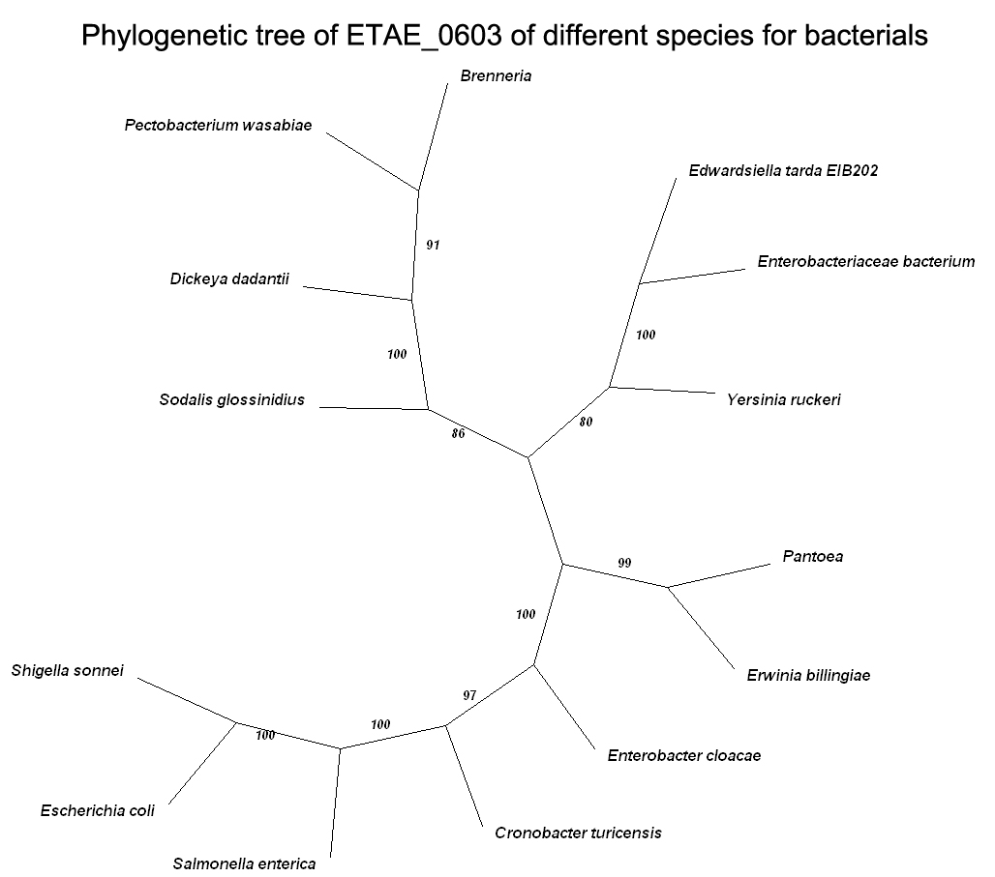

Fig1-1C, Phylogenetic tree of ETAE_0603 of different species of bacteria. The value of branch node stands for confidence. Equivalent 95% statistics probability if exceed 70, but it is incredible when lower than 50.

Phylogenetic analysis. Edwardsiella tarda EIB202 ETAE_0603 (YP_003294661.1) was performed a BLAST on NCBI. A multiple sequence alignment was created with the amimo acid sequences from other bacteria species using ClustalX. Unrooted phylogenetic tree was constructed based on the sequences using MEGA version 4.0, then was adjusted by TreeView to make it more readable. The sequences used in the phylogenetic tree are as follows: Edwardsiella tarda EIB202 organic solvent tolerance protein (YP_003294661.1), Enterobacteriaceae bacterium organic solvent tolerance protein (ZP_07951739.1), Yersinia ruckeri hypothetical protein yruck0001_24770 (ZP_04617072.1), Pectobacterium wasabiae organic solvent tolerance protein (YP_003261170.1), Brenneria LPS-assembly protein lptD (ZP_09014142.1), Dickeya dadantii Organic solvent tolerance protein (YP_003335106.1), Pantoea organic solvent tolerance protein (YP_004114517.1), Sodalis glossinidius organic solvent tolerance protein (YP_454107.1), Erwinia billingiae organic solvent tolerance protein (YP_003740085.1), Enterobacter cloacae unnamed protein product (YP_003943194.1), Cronobacter turicensis LPS assembly outer membrane complex protein LptD (YP_003209049.1), Escherichia coli organic solvent tolerance protein (ZP_07123224.1), Shigella sonnei organic solvent tolerance protein (YP_309092.1), Salmonella enterica subsp. enterica serovar Typhi organic solvent tolerance protein (NP_454705.1).

- ETAE_2430

Fig 1-2A, CDD of ETAE_2430 of Edwardsiella tarda EIB202 (NCBI: gi|269139775)

10 20 30 40 50 60 70 80 90 100
....|....|....|....|....|....|....|....|....|....|....|....|....|....|....|....|....|....|....|....|
Lutiella_nitroferrum --MNSAPQLDTAASPNAVD----AGS-LLDSIIEQSRIATNDSEKGHTRDLIGELVAQVLEGSVTVSRDLSASIDARIAELDALLSSQLNEVMHHPEFQK
Azoarcus MTARDEHLVRTSASPQVEA----EGAGLLDSLIARSRVAVDEAEHDRTRDLIGELVQEVMSGALPLTCDLAASIDARIAELDELISAQLNEIMHDPEFQR
Burkholderia_multivorans ---MNQQTAPAQASGAEYA----AGTSLLDEIVEKSKVAKSDSEHARAKDLIGELVHQVLDGTVVVSDNLSATIDARVAELDRLISAQLSAVMHAPEFQR
Herbaspirillum_seropedicae --MSAQAHIEAAASAAPAA----AGSTLLDDIVEQSKVAKSSSEHDRAKDLISELVSQVMEGTVVVSENLSATLDARIAELDRLISSQVSAIMHAPEFQK
Acinetobacter_calcoaceticus -----MNNTQSAAIPLVEN----EQVNLLDSIVEESRIARNEEEHSRAKSLIGELAKEVMAGTITVSENMTLSIDKRIAEIDALISSQLSQIMHNEQFQK
Terriglobus_saanensis --MEEAKLADSLVLTDEAS-EVAQEGSLLDKLVAQGRFARTAESRERGKDLIKEFISQVLEGHMTVSRDAEAAIQERIAQIDRIISEQLNEILHHPSFQK
Granulicella_mallensis --MSTTKTSVAAATSTVAANGEAQDVSLLDQIVAEGRFSKDAASQERGRDMIKEFVAQVLEGHMTVSRDAEATIQTRIAQIDQLISLQLNEILHHPSFQK
Acidobacterium --MSSAANPLASASTAEAV--ETGEPSLLDQIVAQGRFSREAGDLERGKDLVKEFVSQVLEGQMTLSKDAEATISARIAQLDRLISIQLNEVIHHPSFQK
Gemmatimonas_aurantiaca --MADPTQAAAQSVTTDAE------LSLLDQIVEQGRMGKDADAKSKGKDLVKRFVSEVLEGSITINRDTETMINARIAQIDHLLSLQLNEILHHPEFQR
Edwardsiella_tarda_EIB202 --MSEQNLPESSAAESAAL-----EGGLLDSIIAETRMARSDLEKARARDLLGEWVSEVLSGTVTVSGDVLASIEARIAQIDALLSAQLSAIMHEPAFQK
Yersinia_enterocolitica --MSDIQILGA-ASQTELQ------HDYLDQIIDDTQAIRREEDRGKLKHQLDNFLTEVASGAIIVSNDLVGSIEARIAAIDALLSAQVSNIIQAPAFQK
Rahnella --MSDIQVMNA-SAQAEQS------GDYLDQIIDNTQAIRRESDRNKVKSQLDNFLSEVASGAVIVSNDLVGSIEARIAAIDELLSSQVSKIIQAPEFQR
Citrobacter_youngae --MSSELMPNV-VGTTSLS------NELLDQVIDNTQAIRRESDRDRMKAQLNNFLAEVVSGAVTISSDLIGSIEQRITAIDELLSQQVSLIIHSSEFQK
Enterobacter_asburiae --MNNERIATL-SEGNAVT------ESYLDQIIDNTQAIRRESDRGRVRLQLNNFLEEVVSGSVVISSNLIGSIEERIVAIDELLSKQISVIMHNTAFQK
Escherichia_coli --MTIASTLGQ-NETQYAT------DDCLEEIINNTRAVRQDSEKNRFKLQVNNFLAEVASGSLVISSDLIGSIEKRIADIDKLMSEQLSLIMHATEFQK
Photorhabdus_asymbiotica --MEQSVVEQQELQATEAS------GDFLDQIIDNTQAIRRETDRDRVKSQLDQFLSEVTAGSLVVSGDLVNSIEERIAAIDALMSAQLSLVLHHPEFQR
Clustal Consensus *:.:: : : : : . :* * : :. : :. *:. :* ::* *:. ::: **:

110 120 130 140 150 160 170 180 190 200
....|....|....|....|....|....|....|....|....|....|....|....|....|....|....|....|....|....|....|....|
Lutiella_nitroferrum LEASWRGLKYLVAESETSTMLKIKVLNASKKDLVKDFKASPEFDQSALFKKIYEEEYGTFGGAPYAALVGDYEFTRHPEDFYLLDELSHVAASAHAPLIS
Azoarcus LEGSWRGLKYLVDAAETGPMLKLRMLNVSKKELIKDFRQAAEFDQGALFKKVYEEEYGTFGGAPFAALVGDYEFSRHPEDLYLLEELAHVAAAAHAPFIG
Burkholderia_multivorans LESTWRGLDYLVKESNTGQTIKIKALHAPKRDLVRDFKGASEFDQSALFKKVYEEEFGTFGGSPFGALIGDYEISRQPEDMYFIEQMSHVAAAAHAPFIA
Herbaspirillum_seropedicae LEGSWTGLNYLVRNTTVGENQKIKILNATKKELVKDFNSALEFDQSAMFKKVYEEEFGTFGGAPFGALLGDFEITRQPEDMYFIEQMSRIAAASHAPFIT
Acinetobacter_calcoaceticus IESTWRGLYYFCQETPSNPLIKIRMLNTTKKELVKDFQGATDFDQSTLFKKIYEEEYGSFGGAPYSALIGDFEFDRTPSDMYLLEQISHVAAAAHAPFIS
Terriglobus_saanensis LEGTWRGIRYLMDQSETNSMLKLKVLPVSKRELLRDLQRASEFDQSSLFKKVYEEEFGIFGGAPFAALIGDYEFSKSPEDMDLLQRVAQVAASAHAPFLS
Granulicella_mallensis LEGTWRGIRYLMDQSETNSMLKIKVLNVSKRELLKDLQRASEFDQSSLFKKVYEEEFGVFGGAPFAALIGDYEFGRGPEDIELLERVAQVASAAHAPFLS
Acidobacterium LEATWRGIKYLMDQSETNDMLKIKVLNASKKDLLRDLQRAPEFDQSALFKKVYEEEFGVFGGAPFAAMVGDYEFGRGPEDLELLEKIGQVASAAHAPFLS
Gemmatimonas_aurantiaca LESSWRGLQYLIKNSETGTMLKVKVLNVSKKDLLRDLQRAPEFDQSALFKKIYEEEYGVFGGTPFGAMVGDYYFDKSGQDIELLEKISNVAAAAHAPFIS
Edwardsiella_tarda_EIB202 LEGSWRGLHYLVHQSETGTGLKIRMLNVSRADLIRDFKSAAEFDQSALFKKVYEEEYGTFGGAPFAAMIGDYEFSNHPEDLFLLEEISHVAAAAHAPFLS
Yersinia_enterocolitica MESSWRGLHKLVQSSTTEN-TKVRLFNCTKKELVRDFKSASDFDQSALFKNIYESEYGTFGGEPFSAFVGDFEFDAMPEDVQLLEQISHVAAAAHAPFLT
Rahnella MESSWRGLHKLVQSSVTEN-TKVRVFNCTKKELLRDFKSASDFDQSSLFKSIYESEYGTFGGDPYSAFVGDFEFDCMPEDVQLLEQISHVAAAAHAPFLS
Citrobacter_youngae RESSWRGLHKLVQSSVTEN-TQIRLLQCTKQELIKDFKEASDFDQSLLFKSIYESEYGTFGGVPFSAFVGDFQFDNTPQDISLLEQISHVAAAAHAPFLS
Enterobacter_asburiae RESSWRGLQKLIKASVTDN-TKIRLLQCNKQDLIKDFRSASDFDQSMLFKCVYESEYGTFGGVPFSAFVGDFEFDNTPQDIDLLEQISHVAAAAHAPFFS
Escherichia_coli IESAWTGLYKLVQSSVTEN-VKYTVLHCTKKELLKDFKSASDFDQSVLFKNIYESEYGTFGGTPYSAFVGDFYFDNTPQDIDLLEHISHVAASAHAPFLS
Photorhabdus_asymbiotica LESSWTGLKGLLDQSETDN-TQIRMLNATKTDLIKDFKSASDFDQSMLFKNIYEHEYGTFGGEPYSAFVGDFDFDNSPEDLYLLEQISHVAAAAHAPFIS
Clustal Consensus *.:* *: : : : : : :*::*:. : :***. :** :** *:* *** *:.*::**: : .*. :::.:..:*:::***::

210 220 230 240 250 260 270 280 290 300
....|....|....|....|....|....|....|....|....|....|....|....|....|....|....|....|....|....|....|....|
Lutiella_nitroferrum SASPGLFGLESFTDIGKPRDLAKIFDTVEYAKWKSFRESEDSRYVGLVLPHVLGRLPYG-RDNVPVEAFDFEENVD-GSHHGKYLWTNAAYAYAARLTDA
Azoarcus AVAPAMFGLDNFAELGRPRDLSRIFETVEYAKWKSFRASDDSRYVGLVLPHVLGRLPYG-RDTHPVDAFNFEEDVD-GSDHAKYLWTSAVYSYASRLTAA
Burkholderia_multivorans SASPELLGLESFADLGKPRDLGKVFDTVEYAKWKSFRDSEDSRYVGLTLPRFLGRLPFNPKDGQTAETFNFVEDVD-GTDHDKYLWCNAAWAFAARLTAA
Herbaspirillum_seropedicae AASPELFGLESFSELGKPRDLSKVFDTVEYAKWKSFRESEDSRYVGLTLPRFLGRLPFNPKDGTTVEGFNFVEDVD-GTDHSKYLWCNAAYAFGSKLTKA
Acinetobacter_calcoaceticus AASPSILGLESFTDIDRPRDVSKIFETAEYVQWRSFRDSEDARYVALTLPHVLGRLPYHPKEGTATEGFNFAEDVS-GANHNEYLWMNAAYAFGTRLTNA
Terriglobus_saanensis AASPDLLNLRDFTQLGLPRDIGKIFDTTEYAKWKSFRQSEDSRYVALTLPRVLTRLPYG-KETQQIEGFDFEENVD-GSDHSKYLWSNAAYALGARLTSA
Granulicella_mallensis AASANLLNLEDFTQLGSPRDIGKIFDTTEYAKWKSFRQSEDSRYVGLTLPHVLMRLPYG-KETKAVDDFDYEEAVD-GTDHSKYLWGNAAYALGARLTNA
Acidobacterium AAAPGLMNLSDYTQLGAPRDMSKIFDSTEYAKWKSFRQSDDSRYVALTLPHILMRQPYG-QDTKQIEAFAYEEAVD-GRDHSKYLWGNAAFGLAARMTNS
Gemmatimonas_aurantiaca AASNEMFNLESWSDLDTPRDLAKIFDSTEYARWKGFRASEDSRYVALTAPRILVREPYG-ASTVPVEAFNYEERVD-GTNHDHYCWGNAAFAMAANINKA
Edwardsiella_tarda_EIB202 AASAGMFGLDSLTELSIPRDLAKGFDTVEYAKWKSLRQSEDARYIALALPHVLGRLPYG-ATTVPVESFNFEENVS-GKEHGKYLWLNAAYALGTRLTQA
Yersinia_enterocolitica AASSGMFAMNTFAEMPRPRELGKLFDTSDYARWKSFRQTDDSRYVGLTLPRVIGRLPYG-AKTVPIEMFNFEENIDEEKGGDNYLWVNAAYELAGNIVEA
Rahnella AANPGMFAMGSFSEMPRPRDLGKLFETSDYARWKSFRQSDDSRYVGLTLPRVIGRLPYG-AKTVSVDAFNFEEKIDENNEGASYLWVNAAYDLAGRMVEA
Citrobacter_youngae AIAPGMLSMNDFSELPRPRDLAKMFETTDYARWRSFRQNDDSRYIGLTLPRVLGRLPYG-GKTIPAETFAFEEIISENDTGSDYLWVNSAWELAGRIIES
Enterobacter_asburiae AAAPGMLSMNSFTDMSRPRDMAKLFETTDYARWRSFRQTDDSRYVGLTLPKVLGRLPYG-TKTIPVESFSFEENIAENESSTDYLWVNAAYELAERVVSS
Escherichia_coli AIAPGMLSMNSFSELPYPRDLAKLFETTDYARWRSFRQTDDSRYVGLTLPQSLGRIPYG-MKTVPAETFNFEEHISEDNSGKDYLWVNTAFELACRIVDA
Photorhabdus_asymbiotica SANAGMLGLNDFGELPRPRDLSKLFDTSDYLRWKRFRESDDSRYVGLTLPRVIGRLPYG-AKTIPIEQFCFEEQMREGDS-NSYLWINAAYALAGRMVAA
Clustal Consensus : :: : :: **::.: *:: :* :*: :* .:*:**:.*. *: : * *: : * : * : * * .:.: . .: :

310 320 330 340 350 360 370 380 390 400
....|....|....|....|....|....|....|....|....|....|....|....|....|....|....|....|....|....|....|....|
Lutiella_nitroferrum FAQYGWLAAIRGVEGGGLVEGLPAHTFKTDDGEVALKCPTEVAVTDRTEKLLSDLGFISLVHCKNTDYAAFFSGQSVQKAKTYNTDAANANARLSTQLPY
Azoarcus FAQFGWLAAIRGVEGGGLVEDLPLHTFRTDDGEIGAKCPTELAITDRNEKLLADLGFIALTHCKNSDYAAFFSGQSVQRPRTYNTDAANANARLSAQLPY
Burkholderia_multivorans FDDFGWCAAIRGVEGGGLVEDLPTHTFKTDDGEVALKCPTEIAITDRREKELSDLGFIPLVHCKNSDYAAFFAAQSVQKPKKYSTDSANANAVLSAQLQY
Herbaspirillum_seropedicae FEDFGWCAAIRGVEGGGLVEDLPTHTFKTDEGEVALKCPTEIAITDRREKELSDLGFISLVHCKNTDYAAFFGAQSAQKPKKYNSDAANANAVLSSQLQY
Acinetobacter_calcoaceticus FDMHGWCAAIRGVEGGGLVEGLPVHTFKTQDGEVVFKCPTEIAITDRREKELSDLGFIPLVHCKNTDYAAFFGAQSTQKPKKYDNDTANANSALSSQIQY
Terriglobus_saanensis FARYGWCAAIRGVEGGGLVEDLPAHTFATDEGDIALKCPTEAQITDRREKELADQGLVPLVHCKGTDYAAFFSVQSVNKPRLYDKDAANANARLSAQMPY
Granulicella_mallensis FARYGWCAAIRGVEGGGLVEGLPAHTFRTDEGDVALKCPTEIAVTDRREKELADQGFIPLVHCKGTDYAAFFSVQSGNKPKLYDKDAANANARLSAQLPY
Acidobacterium FARSGWCSAIRGVEGGGLVEGLTAHNFTTDEGDVALKCPTEVTITDRREKELADQGFVPLVHCKGTDKAAFFSVQTVNKPKLYDKPEANANARLSAQLPY
Gemmatimonas_aurantiaca FAMYGWCASIRGVEGGGLVEGLPVHNFRTESGEIAMKCPTEVQITDRREKELADLGFAPLVHQKGTANAAFFSVQSAQKPKTYDDPKASAAARLSAQLPY
Edwardsiella_tarda_EIB202 YAKYGWCAAIRGAEGGGLVEGLPAHTFTTDDGEVELKCPTEVAITDRREKELAELGFIALTHCKGTDYAAFFSTQSVQKPKEYDSDSANANARISCQLQY
Yersinia_enterocolitica FEEYGWSAAIRGVEGGGLVKALPTYNYVSQTGEKVMQCPTEVAISDRREKELADLGFIPLVYCKGTDYAAFFAVQSANKPRKYESELANANARLSSQLQY
Rahnella FEEHGWCAAIRGVEGGGLVKSLPTYNYISQTGEKVMQCPTEVAISDRREKELAELGFIPLIYCKGTDYAAFFAVQSTNKPRKYDSELANANAKLSSQLQY
Citrobacter_youngae FEEYGWCASIRGVEGGGLVKSLPAYNYVSSNGERVMQCPTQIAISDRREKELSELGFIPLVHCKGSDYAAFFAVQSINKPRLYNSDQANANARLSSQLPY
Enterobacter_asburiae FEDYGWCAAIRGVEGGGLVNALPAYNYISENGERLMQCPTQVAISDRREKELSDLGFIPLVHCKGTDYAVFFAVQSVNKPRLYNSDEANANAKLTSQLPY
Escherichia_coli FEEYGWCAAIRGVEGGGLVKSLPAYNYTSHTGERLLQCPTEVAISDRREKELSDLGFIPLIYCKGTDFAAFFAVQSVNKPRLYNTDQANANAKLSSQLQY
Photorhabdus_asymbiotica FEQYGWCAAIRGVEGGGLVEALPTHHYSSVSGEKMLQCPTEVAISDRREKELAELGFIPLVYYKGTDYAAFFSVQSPNKPRKYNSDLANANAKLSTQLQY
Clustal Consensus : ** ::***.******: *. : : : *: :***: ::** ** *:: *: .* : *.: *.**. *: ::.: *. *.* : :: *: *

410 420 430 440 450 460 470 480 490 500
....|....|....|....|....|....|....|....|....|....|....|....|....|....|....|....|....|....|....|....|
Lutiella_nitroferrum IFAVSRIAHYMKSIMRDKIGSFASRQNVQDFLNTWLAQYVLLDDSASQEAKAKYPLREARVDVVEVPGKPGVYRAAAFLRPHFQLDELTISLRLVAELPQ
Azoarcus IFASSRIAHYLKAMMRDKVGSFASRQNVQDFLNAWLAQYVLLDDAASQEAKSKYPLREARVEVVEVPGRPGAYRAAAFLRPHFQLDELTISLRLVAELPQ
Burkholderia_multivorans IFSVSRVAHYLKAMMRDKIGSFASAQNVETFLNRWISQYVLLDDNATQEQKAQFPLREASIQVSEIPGKPGSYRSVAFLRPHFQLDELSISLRLVADLPK
Herbaspirillum_seropedicae IFAVSRIAHYMKSMMRDKIGSFAAASNVEDFLNRWIAQYVLLDDNATQEAKAQFPLREASVQVSEVPGRPGVYRAVSFLRPHFQLDELSVSLRLVAELPQ
Acinetobacter_calcoaceticus IMAVSRIAHYLKAMMRDKVGSFASAGNVEAFLNEWLSQYVLLDDGASQEAKAQYPLREASVKVVEDPAQPGHYKSVVFLRPHFQLDELSVSLRLVTELPQ
Terriglobus_saanensis ILAMSRFAHYLKAMMRDKIGSFTTVAECQKFLNNWISQYVLLDDTASQSAKARLPLREARIEVSEVPGKPGAFRAVAFLKPHFQLDELTISLRLVADLPD
Granulicella_mallensis ILAMSRFAHYLKAIMRDKLGSFMSRDECEIFLNQWISHYVLSNDVATHAAKAKLPLREASIQVSEVPGKPGAYRAVAFLKPHFQLDELTISLRLVADLPE
Acidobacterium IMAMSRFAHYLKAMMRDKIGSAMSRVEAEKFLNQWVNQYVLADDTGSAAAKAKRPLREARIEVMSVPGNAGALRAVAFMRPHFQLDELTVSLRLVADLPA
Gemmatimonas_aurantiaca IFATSRFAHYLKVMMRDKIGGYTSRAEIDVFLNRWIQNYIALEDAG-ASIKARKPLSEARIDVVEVPGKPGAYRAVAFLKPHYQLDELAVSMRLVADLPQ
Edwardsiella_tarda_EIB202 IMATSRFAHYLKSMVRDKIGSFMSRSECEYFLNQWISNYVVGSDDAGQDIKAKYPLREARIDVSDIPGKPGFYKAVAYLKPHFQLEGLTASLRLVADLPP
Yersinia_enterocolitica ILTTSRFAHYLKVIVRDKVGSFMSKTDCQHFLQDWINQYVVASDDAGPIIKASHPLRDAIIEVVDVPGAPGHYRAVAYLKPHFQLEGLSMSLRLVAELPA
Rahnella IMTTSRFAHYLKSIVRDKVGSFMSKSECQNFLQNWINQYVVGSDNVGPTIKASHPLREAVVEVVDVPGSPGSYRAVAYLKPHFQLEGLSMSLRLVAELPA
Citrobacter_youngae ILATSRFAHYLKSIVRDKIGSFMSRAECEEYLQKWIMQYVVASDNAGPETKARYPLREAKIDVVEVPGFPGTYRAIAWLKPHFQLEGLSMSLRLVADLPA
Enterobacter_asburiae ILVTSRFAHYLKSMVRDKVGSFMSRTECQDYLQKWIMKYVVASDVAGATTKARYPLRDARIEVVDVPGSPGTYRAIAYIKPHFQLEGVNMSLRLVADLPA
Escherichia_coli ILATSRFAHYLKVIVRDKVGSFMSKTECQTYLQNWIMQYVVASDSAGQDTKARYPLREASVEVVEIPGSPGSYRAIAWIKPHFQLEGLSMSLRLVADLPS
Photorhabdus_asymbiotica IMTTSRFAHYLKMIVRDKVGSFMSRGECQTYLQSWINQYIVGSDTVGAEIKASHPLREARVDVVEVPGSPGTYRAVAYLRPHFQLEGLSMSLRLVADLPP
Clustal Consensus *: **.***:* ::***:*. : : : :*: *: :*: .* *: ** :* :.* . *. .* :: :::**:**: : *:***::**

....|.
Lutiella_nitroferrum PAG---
Azoarcus PAR---
Burkholderia_multivorans PANS--
Herbaspirillum_seropedicae AGKS--
Acinetobacter_calcoaceticus SSN---
Terriglobus_saanensis SARN--
Granulicella_mallensis SARS--
Acidobacterium PAK---
Gemmatimonas_aurantiaca PAK---
Edwardsiella_tarda_EIB202 PAQG--
Yersinia_enterocolitica STGA--
Rahnella STGA--
Citrobacter_youngae AAGA--
Enterobacter_asburiae AASS--
Escherichia_coli SVSAAA
Photorhabdus_asymbiotica SSAA--
Clustal Consensus .
Fig 1-2B, Alignment of ETAE_2430 of different species of bacteria
*Identical;:Similar;.Normal

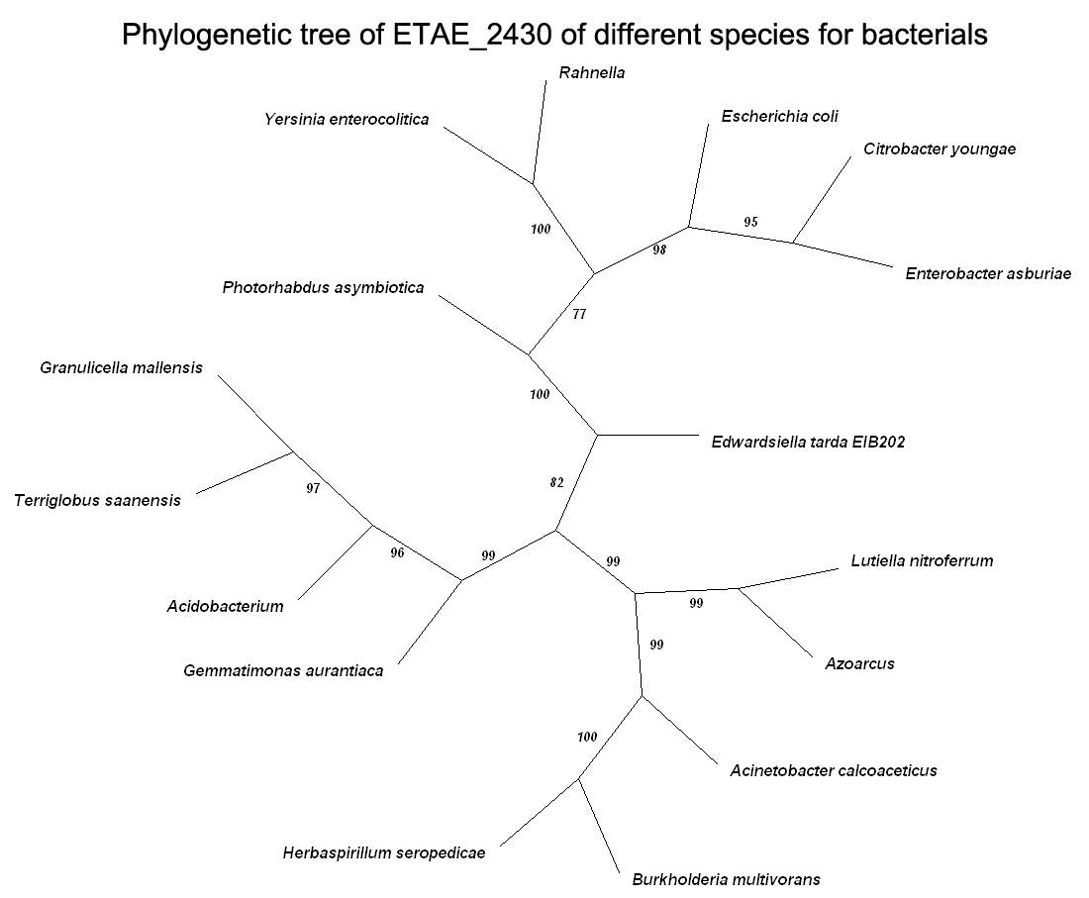

Fig1-2C, Phylogenetic tree of ETAE_2430 of different species of bacteria. The value of branch node stands for confidence. Equivalent 95% statistics probability if exceed 70,but it is incredible when lower than 50.

Phylogenetic analysis. Edwardsiella tarda EIB202 ETAE_2430 (YP_003296476.1) was performed a BLAST on NCBI. A multiple sequence alignment was created with the amimo acid sequences from other bacteria species using ClustalX. Unrooted phylogenetic tree was constructed based on the sequences using MEGA version 4.0, then was adjusted by TreeView to make it more readable. The sequences used in the phylogenetic tree are as follows: Edwardsiella tarda EIB202 type VI secretion system protein EvpB (YP_003296476.1), Lutiella nitroferrum type VI secretion protein, EvpB/VC_A0108 family (ZP_03699807.1), Terriglobus saanensis EvpB tamily type VI secretion protein (YP_004181908.1), Azoarcus unnamed protein product (YP_932808.1), Granulicella mallensis type VI secretion protein EvpB/VC_A0108 family (AEU37179.1), Burkholderia multivorans EvpB family type VI secretion protein (YP_001581110.1), Photorhabdus asymbiotica hypothetical protein PAU_02281 (YP_003041117.1), Herbaspirillum seropedicae SmR1 hypothetical protein Hsero_4036 (YP_003777415.1), Yersinia enterocolitica conserved hypothetical protein (CAX67772.1), Rahnella type VI secretion protein, EvpB/VC_A0108 family (YP_004215620.1), Citrobacter youngae type VI secretion protein, EvpB/VC_A0108 family (ZP_06352363.1), Acidobacterium type VI secretion protein EvpB (YP_004210118.1), Acinetobacter calcoaceticus hypothetical protein BDGL_000640 (ADY81226.1), Enterobacter asburiae EvpB family type VI secretion protein (YP_004821681.1), Escherichia coli EvpB/family protein type VI secretion protein (EGB69697.1), Gemmatimonas aurantiaca hypothetical protein GAU_3871 (YP_002763383.1).

- ETAE_0191

Fig 1-3A, CDD of ETAE_0603 of Edwardsiella tarda EIB202 (NCBI: gi|269137549)

10 20 30 40 50 60 70 80 90 100
....|....|....|....|....|....|....|....|....|....|....|....|....|....|....|....|....|....|....|....|
Enterobacter_cloacae --MKKLLPILIGLSLTGLSTISHAENLMQVYQQARISNPDLRKSAADRDAAFEKINEARSPLLPQLGLGADYTYTNGFRDNNGINSNATSAALTLTQTIF
Rahnella --MKKLLPLLIGLSLGGFSTISQAENLMQVYQQARTSNPDLRKSAADRDAAFEKINESRSPLLPQLGLGADYNYTNGYRDANGVNSDVGSASLQLTQTIF
Escherichia_fergusonii_ECD227 MQMKKLLPILIGLSLSGFSALSQAENLMQVYQQARLSNPELRKSAADRDAAFEKINEARSPLLPQLGLGADYTYSNGYRDANGINSNATSASLQLTQSIF
Shigella_dysenteriae --MKKLLPILIGLSLSGFSSLSQAENLMQVYQQARLSNPELRKSAADRDAAFEKINEARSPLLPQLGLGADYTYSNGYRDANGINSNATSASLQLTQSIF
Salmonella_bongori MQMKKLLPILIGLSLSGFSTLSQAENLMQVYQQARLSNPELRKSAADRDAAFEKINEARSPLLPQLGLGADYTYSNGYRDANGINSNETSASLQLTQTLF
Citrobacter MQMKKLLPILIGLSLSGFSTLSQAENLMQVYQQARLSNPELRKSAADRDAAFEKINEARSPLLPQLGLGADYTYSNGYRDSNGVNSNATSASLQLTQTLF
Cronobacter_sakazakii --MKKLLPILIGLSLTGFSAMSQAENLLQVYQQARLSNPDLRSSAADRDAAFEKINEARSPLLPQLGLGADYTYNSGFRDNDGVDSTAKSASLQLTQTIF
Pantoea_vagans --MKKLLPFFIGLSLGGFSFASQAEDLLQVYQQARLSNPDLRSAAADRDSAFEKINEARSPLLPQLGLGADYTYNNGYRDSSGLHSNTTSGSLQLTQTIF
Serratia_symbiotica --MKKLLPFLIGLSLGGFSAMSQAENLLQVYKQARESNPELRKTAADRDAAFEKINEARSPLLPQLGLTAGYAYGRGYRDANNINSTMTNGSLALTQTIF
Yersinia_ruckeri MQMKKLLPLLIGLSLAGFSTMSQAENLLQVYKQARESNPDLRKSAADRDAAFEKINESRSPLLPQLGLGADYAYSQGFRDSNGVNSNVTAGSLTLTQTIF
Edwardsiella_tarda_EIB202 --MKKLLPLLIGLSLSGFSALSQAENLMQVYQQAKESNPDLRQAAANRDAAFEKINESRSPLLPQLGLGADYTYTNGFRDSSGLNSNNYGASLALTQTIF
Clustal Consensus ******::***** *:* *:**:*:***:**: ***:**.:**:**:*******:********** *.* * *:** ..:.* .:* ***::*

110 120 130 140 150 160 170 180 190 200
....|....|....|....|....|....|....|....|....|....|....|....|....|....|....|....|....|....|....|....|
Enterobacter_cloacae DMSKWRALSLQEKTAGIQDVSYQTDQQTLILNTATAYFNVLSAIDSLSFTEAQKQAVYRQLDQTTQRFNVGLVAITDVQNARSQYDTVLANEVTARNNLD
Rahnella DMSKWRALTLQEKTAGIQDVSYQTDQQSLILNSATAYFNVLSAIDSLSYTEAQKQAIYRQLDQTTQRFNVGLVAITDVQNARSQYDTVLANEVTARNNLD
Escherichia_fergusonii_ECD227 DMSKWRALTLQEKAAGIQDVTYQTDQQTLILNTATAYFNVLNAIDVLSYTQAQKEAIYRQLDQTTQRFNVGLVAITDVQNARAQYDTVLANEVTARNNLD
Shigella_dysenteriae DMSKWRALTLQEKAAGIQDVTYQTDQQTLILNTATAYFNVLNAIDVLSYTQAQKEAIYRQLDQTTQRFNVGLVAITDVQNARAQYDTVLANEVTARNNLD
Salmonella_bongori DMSKWRALTLQEKAAGIQDVTYQTDQQTLILNTANAYFKVLNAIDVLSYTQAQKEAIYRQLDQTTQRFNVGLVAITDVQNARAQYDTVLANEVTARNNLD
Citrobacter DMSKWRALTLQEKSAGIQDVTYQTDQQTLILNTATAYFNVLNAIDVLSYTQAQKDAVYRQLDQTTQRFNVGLVAITDVQNARSQYDTVLANEVTARNNLD
Cronobacter_sakazakii DMSKWRALTLQEKTAGIQDVTYQTDQQTLMLNTATAYFQVLSAIDALSYTEAQKQAIYRQLDQTTQRFNVGLVAITDVQNARAQYDNVLANEVTARNNLD
Pantoea_vagans DMSKWRALTLQEKAAGIQDVTYQVAQQDLILNTATAYFNVLKAIDTLSYTEAQKQSIYRELDQTTQRFNVGLVAITDVQNARAQYDSVLANEVTARNNLD
Serratia_symbiotica DMSKWRVLTLQEKTAGISDVTFQTSSQRLILDTATAYFSVLSAIDALSYTQAQKQAVYRTLDQTTQRFNVGLVAITDVQNARSNYDTVLASEVTARNTLD
Yersinia_ruckeri DMSKWRALTLQEKTAGIQDVTFQTSEQQLILNTAIAYFNVLRAIDTLSYTEAQKEAVYRQLDQTTQRFNVGLVAITDVQNARATYDSILAQEVTAQNGVD
Edwardsiella_tarda_EIB202 DMSKWRQLSLTEKQAGIQDVSYQSSEQTLMLNTATAYFNVLRAIDQLTYTEANKQAIYNQLDQTTQRFNVGLVAITDVQNARAQYDQVLAQEVSARNNLD
Clustal Consensus ****** *:* ** ***.**::* .* *:*::* ***.** *** *::*:*:*:::*. **********************: ** :**.**:*:* :*

210 220 230 240 250 260 270 280 290 300
....|....|....|....|....|....|....|....|....|....|....|....|....|....|....|....|....|....|....|....|
Enterobacter_cloacae NAVEQLRQVTGNYYPELASLNVTNFKTDKPQAVNALLKEAENRNLALLQARLSQDLAREQIRYAETGHMPTVGLTASTGISDTKYNG-NNAT----SSQY
Rahnella NALESLRQVTGMYYPQLSSLNVDNFNTTRPQPVATLLKEAESRNLSLLSARLSQDLAREQIRYAETGHMPTVDLTASTGISNTKYHG-DKTGG---SSSY
Escherichia_fergusonii_ECD227 NAVEQLRQITGNYYPELAALNIDNFKTDKPQPVNALLKEAEKRNLSLLQARLSQDLAREQIRQAQDGHLPTLDLTASTGISDTSYSG-SKTRG-ANSAQY
Shigella_dysenteriae NAVEQLRQITGNYYPELAALNVENFKTDKPQPVNALLKEAEKRNLSLLQARLSQDLAREQIRQAQDGHLPTLDLTASTGISDTSYSG-SKTRG-AAGTQY
Salmonella_bongori NAVEELRQVTGNYYPELASLNVEHFKTDKPKAVNALLKEAENRNLSLLQARLSQDLAREQIRQAQDGHLPTLNLTASTGVSDTSYSG-SNTHG--PGSQY
Citrobacter NAVEQLRQVTGNYYPELASLNVDGFKTNKPQAVNALLKEAENRNLSLLQARLSQDLAREQIRQAQDGHLPTLDLTASTGVSDTSYSG-SKTRASDAGTRY
Cronobacter_sakazakii NALEQLRQVTGNYYPQLASLNVDNFKTTKPAAVNALLKEAEQRNLTLLQARLSQDLAREQIRYAETGHMPTLGLTASSSVSDTDYSG-SKTSG-SAASRY
Pantoea_vagans NNVETLRQITGMDYMSLASLSIDRFRTDKPEAVSALLKQAEARNLSLLSARLNQDLAREQIRSAETGHMPTLDLTASTGMSNSKYGG-SRANQ---SQGS
Serratia_symbiotica NALEKLRQVTGTFYPELASLDTDRFSTQRPEAVNNLLKEAEAHNLSLLSARLSQDLAREQIRLAQTGYMPTINMSASTGITDTKYSG-SSSSG------D
Yersinia_ruckeri NALENLRQITGVYYPELASLNVDRLKTKRPDAVNNLLSEAEKRNLTLLSARLSQDLAREQIKLAETGYMPTINATASSKISNNRYSG-NAVSD-----QQ
Edwardsiella_tarda_EIB202 NSLEALRQITGQYYPQLSALNIDRFSTKRPDDVKALLQEAEKRNLQLLSARLSQDLARQQIKYAETGYMPTLNLTASTGVSNTDYNSLSNAQKETLRGGN
Clustal Consensus * :* ***:** * .*::*. : * :* * **.:** :** **.***.*****:**: *: *::**:. :**: :::. * . .

310 320 330 340 350 360 370 380 390 400
....|....|....|....|....|....|....|....|....|....|....|....|....|....|....|....|....|....|....|....|
Enterobacter_cloacae TDRNIGQNQIGLNFSLPLYSGGSVTSQVKQAQYNFVGASEQLESAHRSVVQTVRSSFNNINASISSINAYKQAVVSAQSSLDAMEAGYQVGTRTIVDVLD
Rahnella QDADAGQNKIGLSFSLPLYSGGSVTSQVKQAQYNFVGASEQLESAHRSVVQTVRSSFNNISASISSINAYKQAVVSAQSSLDAMEAGYQVGTRTIVDVLD
Escherichia_fergusonii_ECD227 DDSNMGQNKVGLSFSLPIYQGGMVNSQVKQAQYNFVGASEQLESAHRSVVQTVRSSFNNINASISSINAYKQAVVSAQSSLDAMEAGYSVGTRTIVDVLD
Shigella_dysenteriae DDSNMGQNKVGLSFSLPIYQGGMVNSQVKQAQYNFVGASEQLESAHRSIVQTVRSSFNNINASISSINAYKQAVVSAQSSLDAMEAGYSVGTRTIVDVLD
Salmonella_bongori DDSNMGQNKIGLNFSLPIYQGGMVNSQVKQAQYNFVGASEQLESAHRSVVQTVRSSFNNINASISSINAYKQAVVSAQSSLDAMEAGYSVGTRTIVDVLD
Citrobacter DDSNEGQNKIGLSFSLPLYQGGMVNSQVKQAQYNFVGASEQLESAHRSVVQTVRSSFNNINASISSINAYKQAVVSAQSSLDAMEAGYSVGTRTIVDVLD
Cronobacter_sakazakii ADSKIGQNSIGLSFNLPLYSGGSVTSQVKQAQYSFVGASEKLESAHRNVVQTVRSSYNNVNASISSIKAYEQAVVSAQSSLDAMEAGYSVGTRTIVDVLD
Pantoea_vagans TDSITGSNQVGLSFSLPLYSGGSVTSQVKQAQYSFVSASESLESAHRSAVQTVRSSFNNVNASISSINAYKQAVVSAQSSLDASEAGYQVGTRTIVDVLD
Serratia_symbiotica TDSNTGQNKIGLSINLPLYSGGATNSQVQQAQYSFVGASESLESAHRSLVQTVRSSFNNVNASISSINAYKQAVVSAQSSMDAMEAGYQVGTRTIVDVLN
Yersinia_ruckeri RSNDAGQNSIGLSFNLPLYSGGATNSQVKQAQYGFVGASEQLESAHRSVVQTVRSSYNNISASISSINAFKQAVISAQSSLDASEAGYQVGTRTILDVLN
Edwardsiella_tarda_EIB202 GSSYQGQNTVGLSFNLPLYSGGATNSQVKQAQYNFVGASEALDSAHRSVVQNVRSSFNNISAAISGVSAYKQAVVSAQSSLDATQAGYQVGTRTIVDVLN
Clustal Consensus . *.* :**.:.**:*.** ..***:****.**.*** *:****. **.****:**:.*:**.:.*::***:*****:** :***.******:***:

410 420 430 440 450 460 470 480 490 500
....|....|....|....|....|....|....|....|....|....|....|....|....|....|....|....|....|....|....|....|
Enterobacter_cloacae ATTTLYNAKQQLSSARYTYLINQLNIKSALGTLNENDLLALNGALGKPISTSADAVAPENPQQDASADGYANTTPTAKPASVRTTTTSTSSS---KSANP
Rahnella ATTTLYNAKQQLSSARYTYLINQLNIKSALGTLNESDLLALNGALGKPVPTAPDQVAPETPDQDAAADGYGNKTAAAPAPRVQQASASTATTTPKKSGNP
Escherichia_fergusonii_ECD227 ATTTLYNAKQQLANARYNYLINQLNIKSALGTLNEQDLIALNNALSKPVSTNPENVAPQTPEQNAIADGYAPDSP---APVVQQTSVR--AS---NGNNP
Shigella_dysenteriae ATTTLYNAKQELANARYNYLINQLNIKSALGTLNEQDLLALNNALSKPVSTNPENVAPQTPEQNAIADGYAPDSP---APVVQQTSARTTTS---NGHNP
Salmonella_bongori ATTTLYDAKQQLANARYTYLINQLNIKYALGTLNEQDLLALNSTLGKPIPTSPESVAPETPEQDAAADGYSANTA---APAVQPTAARTTSS---KSGNP
Citrobacter ATTTLYNAKQQLANARYTYLINQLNVKSALGTLNEQDLVALNNTLGKPVSTTPDTIAPENAQQDAAADGYTSNSA---TPAAQPTAARSTSS---TGNNP
Cronobacter_sakazakii ATTTLYNAKQQLSSARYNYLINQLNIKSALGTLNEQDLVALNNSLGKPVSTAPESVAPENPEQDAAVNNMANGGGN--APAMQPAAATRSSNS--NSGNP
Pantoea_vagans ATTVLYNAKQQLSDARYSYLINQLNISYALGTLNEQSLQKLNSQLGKEIPTSPETVAPENAQQTARVDSGPAATG---SSEAARPAARHSSG------NP
Serratia_symbiotica ATTTLYNAKQQLSSARYTYLINQLNIKSSLGTLNENDLLALNGALGKPVSTSPEVLAPATTEQNAYANGYNGDGL-----ATDTTQPARNSG------DP
Yersinia_ruckeri ATTALYNAKQQLANARYDYLINELTIKSSLGTLNQNDLMELNGALDKPISTSATKVTSESS-QSASASSYAQTSAQT-APVSQPTATSTRSAG-----NP
Edwardsiella_tarda_EIB202 ATTALYNAKQNLANARYDYLISQLNIKYALGTLNQNDLLALNGDLSKPVPTAADSIAPDDAAQAAKANGPIPGGG------VR-----------------
Clustal Consensus ***.**:***:*:.*** ***.:*.:. :*****:..* **. *.* :.* . ::. . * * ...

Enterobacter_cloacae FRN
Rahnella FQN
Escherichia_fergusonii_ECD227 FRN
Shigella_dysenteriae FRN
Salmonella_bongori FHN
Citrobacter FRN
Cronobacter_sakazakii FRQ
Pantoea_vagans FGN
Serratia_symbiotica FRH
Yersinia_ruckeri FRN
Edwardsiella_tarda_EIB202 ---
Clustal Consensus
Fig 1-3B, Alignment of ETAE_0191 of different species of bacteria
*Identical;:Similar;.Normal
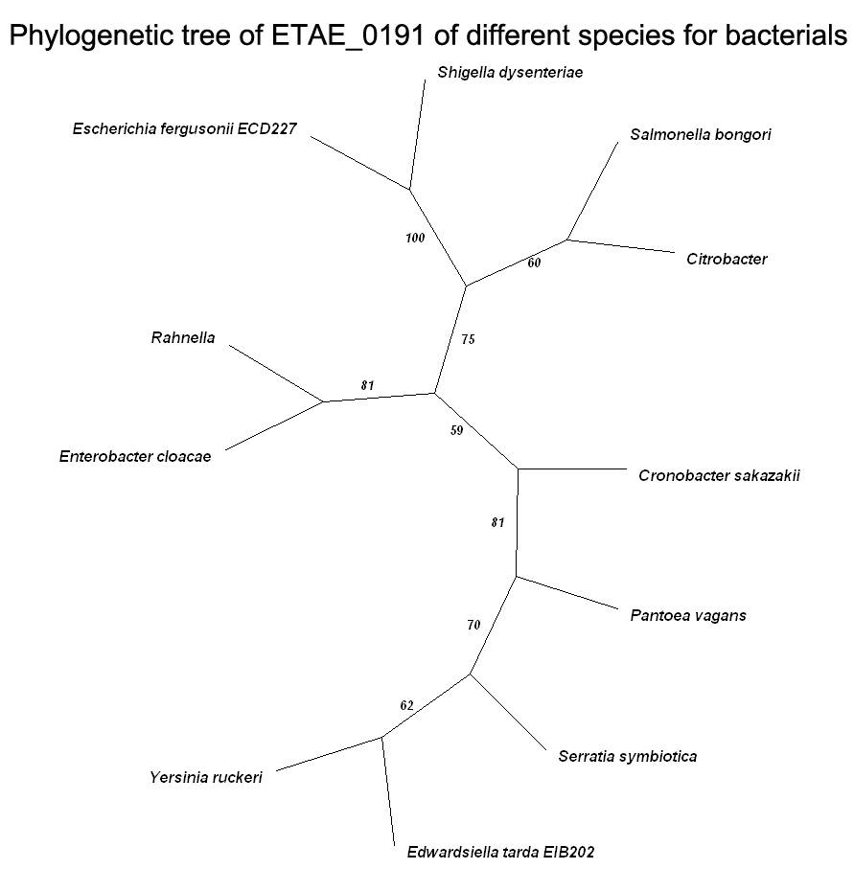

Fig1-3C, Phylogenetic tree of ETAE_0191 of different species of bacteria. The value of branch node stands for confidence. Equivalent 95% statistics probability if exceed 70,but it is incredible when lower than 50.

Phylogenetic analysis. Edwardsiella tarda EIB202 ETAE_0191 (YP_003294249.1) was performed a BLAST on NCBI. A multiple sequence alignment was created with the amimo acid sequences from other bacteria species using ClustalX. Unrooted phylogenetic tree was constructed based on the sequences using MEGA version 4.0, then was adjusted by TreeView to make it more readable. The sequences used in the phylogenetic tree are as follows: Edwardsiella tarda EIB202 outer membrane protein (YP_003294249.1), Enterobacter cloacae unnamed protein product (YP_003940276.1), Escherichia fergusonii outer membrane channel protein (EGC96447.1), Cronobacter sakazakii outer membrane channel protein (EGL73720.1), Salmonella bongori outer membrane protein TolC (YP_004731592.1), Rahnella TolC family type I secretion outer membrane protein (YP_004211385.1), Citrobacter export system outer membrane protein tolC (ZP_04560442.1), Yersinia ruckeri Outer membrane protein tolC (ZP_04616820.1), Pantoea vagans outer membrane protein tolC precursor (YP_003932259.1), Shigella dysenteriae Type I secretion outer membrane protein, TolC precursor (EFW51263.1), Serratia symbiotica putative transport channel (ZP_08039572.1).

- ETAE_2935

Fig 1-4A, CDD of ETAE_2935 of Edwardsiella tarda EIB202 (NCBI: gi|269140278)

10 20 30 40 50 60 70 80 90 100
....|....|....|....|....|....|....|....|....|....|....|....|....|....|....|....|....|....|....|....|
Pectobacterium_atrosepticum -----------------MVLNMKKTFAAGALLALSCSMPA-LADDNK-------------AEYLSDWWHQSINVVGSAHTRFGPQLSSTTYLEYEAFARK
Brenneria ---------------------MKKAFAAGALVALSYSVPA-LADENK-------------PQYLSDWWHQSVNVVGSYHTRFGPQLNNDVYLEYEAFARK
Dickeya_zeae ---------------------MKKILTACAISTLSYSLPT-VAQESA-------------PQYLSDWWHQSINVVGSYHTRFGPQLNNDVYLEYEAFARK
Pantoea_vagans ---------------MWLIIMKYKTLIAGAVLACSLSGAAQAAESD--------------PQYLSDWWHQSVNVVGSYHTRFGPQFNNDVYLEYEAFAKK
Erwinia_billingiae --------------------MKYKILMAGALAALSYSASSTAATDS--------------PEYVSDWWHQSVNVVGSYHTRFGPQFNNDVYLEYEAFAKK
Edwardsiella_tarda_EIB202 --------------------MKKTILAAGALLSCLSTSVTATAADNN-------------GEYLSDWWHQSVNVVGSYHTRFGPFRTNDVYLEYEAFAKK
Serratia ------------------------MLAA-------SYSASSMADSKD-------------SEFVSDWWHQSVNVVGSYHTRFGPQLNNDVYLEYEAFAKK
Escherichia_coli --------------------MKKTLLAAGAVLTLSSSFTVNAAENDK-------------PQYLSDWWHQSVNVVGSYHTRFGPQLRNDTYLEYEAFAKK
Shigella_dysenteriae --------------------MKKTLLAAGVVLALSSSFTVNAAENDK-------------PQYLSDWWHQSVNVVGSYHTRFGPQIRNDTYLEYEAFAKK
Enterobacter_cloacae ------------------MIMKKTLLAAGAVLALSSSFTVNAAENDK-------------PQYLSDWWHQSVNVVGSYHTRFGPQIRNDTYLEYEAFAKK
Klebsiella_pneumoniae --------------------MKKTLLAAGAVVALSTSFTAGAAENDK-------------PQYLSDWWHQSVNVVGSYHTRFGPQIRNDTYLEYEAFAKK
Salmonella_enterica --------------------MKKTLLAVSAALALTSSFTVNAAENDQ-------------PQYLSDWWHQSVNVVGSYHTRFSPKLNNDVYLEYEAFAKK
Pseudomonas_psychrotolerans --------MTFSRLRRVRFGALPLLFCCSAQLLAAPAVATDSAQGETASPAAQQTDNR--SPYLSSWYNQDLTLIGSKDISFGPQPVDDVYLEYEYFGRK
Burkholderia_gladioli MHAGIQNKKKKTKKRPVAGVAVMAALACTSAMAGQPAGATVLAESEVVLPAAPAATVTPPSPYLSDWFHQSIGLIGSKNIRFGPHRTNDLYLEYEYFGRK
Clustal Consensus : * . ::*.*::*.: ::** . *.* . ***** *.:*

110 120 130 140 150 160 170 180 190 200
....|....|....|....|....|....|....|....|....|....|....|....|....|....|....|....|....|....|....|....|
Pectobacterium_atrosepticum DWFDFYGYADVPKFFG-GDPDSRGIWDKGSPLFVEIEPRFSIDKLTGADLSFGPFKEWYIANNVIYDQGRNSGSRQSTWYMGLGTDIDTGTDLSLSLNGY
Brenneria DWFDFYGYIDVPKFFGVGNSNDRGAWDDGSPLFVEIEPRFSIDKLTGADLGVGPFKEWYVANNIIYDHGRSSDSRQSTWYVGLGNDIDTGTDLSLSTNIY
Dickeya_zeae DWFDFYGYIDVPKSFGAGNTPDRGIWDKGSPLFMEIEPRFSIDKLTNTQLGFGPFKEWYVANNIIYDQGRNNDSRQSTWYVGLGTDIDTGTDLSLSANIY
Pantoea_vagans DWFDFYGYLDVPNFFGVGNSNANGVFDHGSPMFMEIEPRFSIDKLTGTSLAFGPFKEWYFANNYIYDMGRNSDNRQNTWYMGLGTDIDTHSDVGLSLNVY
Erwinia_billingiae DWFDFYGYIDATNFFGVGNSNANGIFDHGSPLFMEIEPRFSIDKLTNTDLSFGPFKEWYFANNYIYDMGRNSDNRQNTWFMGLGTDIDTHSDVGLSLNVY
Edwardsiella_tarda_EIB202 DWLDFYGYVDVPKFFGAGNTVDKGIWDKGSPLFMEIEPRFSIDKLTGLNLGFGPFKEWYFANDYVFDMGRNSDSRQNTWYMGLGTDIDTGLPMGLSLNVY
Serratia DWFDFYGYVDVPKFFGVGNTPDRGIWDKGSPMFMEIEPRFSIDKLTGTNLGFGPFKEWYFANNYIYDLGHNADGRQNTWYMGLGTDIDTGLPMSLSMNIY
Escherichia_coli DWFDFYGYADAPVFFG-GNSDAKGIWNHGSPLFMEIEPRFSIDKLTNTDLSFGPFKEWYFANNYIYDMGRNKDGRQSTWYMGLGTDIDTGLPMSLSMNVY
Shigella_dysenteriae DWFDFYGYADAPVFFG-GNSDAKGIWNHGSPLFMEIEPRFSIDKLTNTDLNFGPFKEWYFANNYIYDMGRNKNGRQSTWYMGLGTDIDTGLPMSLSMNVY
Enterobacter_cloacae DWFDFYGYMDAPVFFG-GNTDAKGIWNHGSPLFMEIEPRFSIDKLTGTSLAFGPFKEWYFANNYIYDMGRNKSGRQSTWYMGLGTDIDTGLPMSLSLNVY
Klebsiella_pneumoniae DWFDFYGYIDAPVFFG-GNSTAKGIWNNGSPLFMEIEPRFSIDKLTNTDLSFGPFKEWYFANNYIYDMGRNDSQEQSTWYMGLGTDIDTGLPMSLSLNVY
Salmonella_enterica DWFDFYGYIDIPKTFGWGNGNDKGAWDDGSPMFMEIEPRFSIDKLTGVNLGFGPFKEWYFANNYIYDMGDNKASRQSTWYMGLGTDIDTGLPMGLSLNVY
Pseudomonas_psychrotolerans GPFELYGYIDVPRVLGIGNSHDSGVWDRGSPLFMEHEPRISIDQLSGRSLAFGPFKEWYLAFDWIYDHGSSRASRQNTLYAGFGTDIETHTPVLLSANLY
Burkholderia_gladioli GPFDLYGYVDVPRVLGVGNGYDGGFTNKGSPVFSEQEPRVSIDHLLGKSLAIGPFKEWYVAFDWIYDQGHNTPGRQNTLYAGIGTDIDTHTPLMLSANLY
Clustal Consensus . :::*** * . :* *: * : ***:* * ***.***:* . .* .*******.* : ::* * . .*.* : *:*.**:* : ** * *

210 220 230 240 250 260 270 280 290 300
....|....|....|....|....|....|....|....|....|....|....|....|....|....|....|....|....|....|....|....|
Pectobacterium_atrosepticum AKYQWQNYGAANENEWDGYRVKVKYSYPLGSLM-GGNVSYISFTNFDFGSELR-DKSN------SSRTNNSIASSHILALGYDHWHYSFVARYFHNGGQW
Brenneria AKYQWKNYGAGNENEWDGYRFKVKYAYPLGTLW-GGNVAYIGFTNVDFGSDLR-NKDG------RSRTGNSIASSHILSLGYDHLHYSVVARYFHNGGQW
Dickeya_zeae AKYQWQNYGAPNEDQWDGYRFKIKYFYPLTSVW-GGKLTYIGFTNFDFGSDLA-NAAG------PSRTSNAIASSHILALNYDHWHYSVVARYFHNGGQW
Pantoea_vagans AKYQWENYGAANENSWDGYRFKVKYFVPITTLW-GGNLGYVGFTNFDWGSDLN-EKGG------SSRTSNSIASSHILSLGYDHWHFSAVARYFHNGGQW
Erwinia_billingiae AKYQWENYGAANENSWDGYRFKVKYFVPITSLW-GGNLSYIGFTNFDWGSDLR-DETG------PSRTSNSIASSHILSLGYDHWHYSFVARYFHNGGQW
Edwardsiella_tarda_EIB202 GKYQWENYGAANENSWDGYRVKVKYFVPLTELW-GGNLNYIGFTNFDFGSRLG-DKSGVGSNGNQLRSNNSIASSHILALNYTHWHYSVVARYFHNGGQW
Serratia AKYQWENYQAANENSWDGYRFKVKYFVPLTQLW-GGNLSYIGFTNFDFGSDLGKDSNWTDGTGKQVRTSNSIASSHILALNYDHWHYSFVARYFHNGGQW
Escherichia_coli AKYQWQNYGAANENEWDGYRFKVKYFVPITDLW-GGQLSYIGFTNFDWGSDLG-DDSGYANNGIKTRTNNSIASSHILALNYDHWHYSVVARYWHNGGQW
Shigella_dysenteriae AKYQWQNYGAANENEWDGYRFKIKYFVPITDLW-GGQLSYIGFTNFDWGSDLG-DDSGNAINGIKTRTNNSIASSHILALNYDHWHYSVVARYWHDGGQW
Enterobacter_cloacae AKYQWQNYGAANENEWDGYRFKVKYFVPITQLW-GGNLSYIGFTNFDWGSDLG-DNDFRDLNGKKARTNDSIASSHILALNYDHWHYSVVARYWHNGGQW
Klebsiella_pneumoniae AKYQWQNYGASNENEWDGYRFKVKYFVPLTDLW-GGSLSYIGFTNFDWGSDLG-DDNFYDLNGKHARTSNSIASSHILALNYAHWHYSVVARYFHNGGQW
Salmonella_enterica AKYQWQNYGASNENEWDGYRFKVKYFVPITDLW-GGKLSYIGFTNFDWGSDLG-DDS--------NRTSNSIASSHILALNYDHWHYSVVARYFHNGGQW
Pseudomonas_psychrotolerans GRRQWENYGAANENSWDGYRAQLKYIWPLAKFDNGASLTYVGFTNFDFGSKLG-DEPG--------RTANATVSTNVLLYAFTHLRFMFAARHFHNGGNW
Burkholderia_gladioli LHRQWENYGAANQNSWDGYRAQMKYILPLGTFH-GGNLLYVGFFNYDFGSKLR-EETGD-----NTRTDTAFVSTNVLIYSFKHWRFWTAARYFHHGGQW
Clustal Consensus : **:** * *::.***** ::** *: . *..: *:.* * *:** * : *: : .*:::* : * :: .**::*.**:*

310 320 330
....|....|....|....|....|....|
Pectobacterium_atrosepticum ADGAELNFGKGPFEVKSTGWGYYLVVGYNF
Brenneria ADGAELNFGQGPFEVKSTGWGYYLVVGYSF
Dickeya_zeae ADGTELDFGRGPFNVRSTGWGYYLVAGYNF
Pantoea_vagans ADGQELNFGKGPFEVKSTGWGYYLVAGYNF
Erwinia_billingiae ADGQELNFGNGQFEVKSTGWGYYLVAGYNF
Edwardsiella_tarda_EIB202 KEGAALG---DDLHP--TGWGYYLVVGYNF
Serratia QDGAEIGTPQGPIKS--TGWGYYLVAGYNF
Escherichia_coli NDDAELNFGNGNFNVRSTGWGGYLVVGYNF
Shigella_dysenteriae NDDAELNFGNGNFNVRSTGWGGYLVVGYNF
Enterobacter_cloacae NDDASLNFGNGDFSVRSTGWGGYLVVGYNF
Klebsiella_pneumoniae ADDAKLNFGDGDFSVRSTGWGGYFVVGYNF
Salmonella_enterica QNGAKLNWGDGDFSAKSTGWGGYLVVGYNF
Pseudomonas_psychrotolerans RDGTELNFGEGDFEGRSNGWGYYAGVGYQF
Burkholderia_gladioli -AGTALNFGDGPFQNRSNGWGYYASVGYQF
Clustal Consensus . :. . : .*** * .**.*
Fig 1-4B, Alignment of ETAE_2935 of different species of bacteria
*Identical;:Similar;.Normal

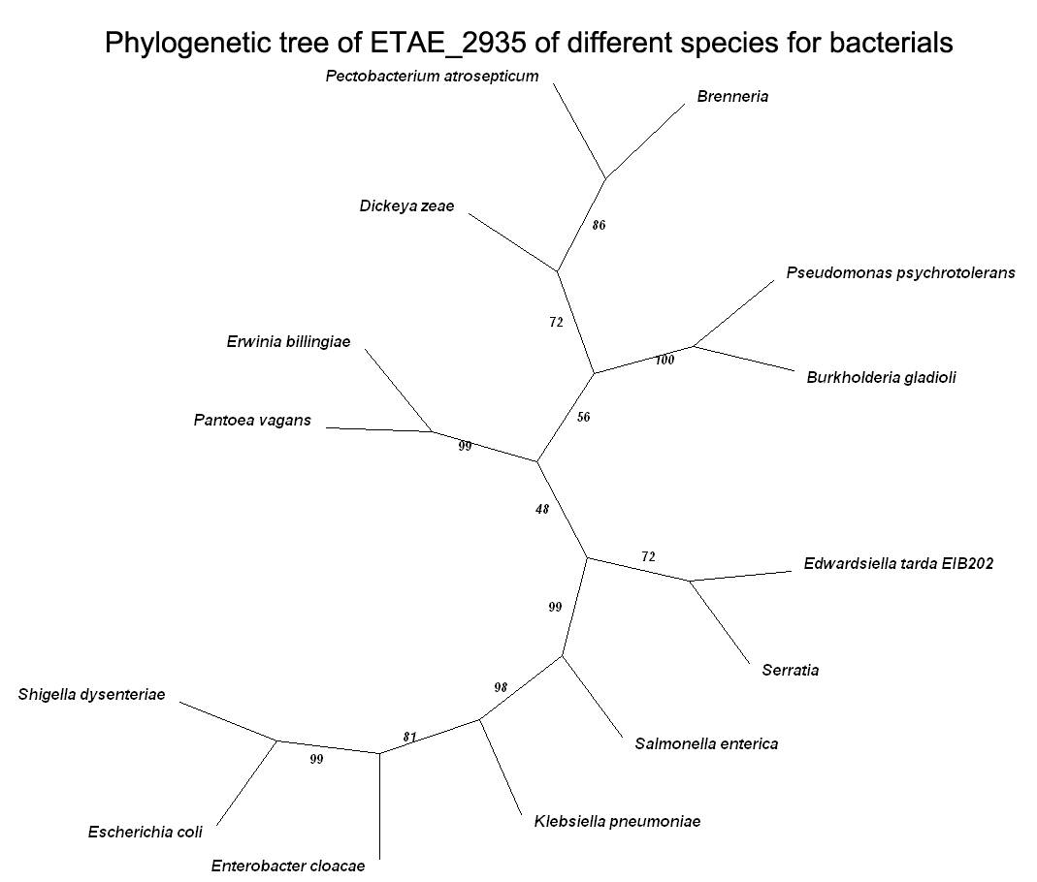

Fig1-4C, Phylogenetic tree of ETAE_2935 of different species of bacteria. The value of branch node stands for confidence. Equivalent 95% statistics probability if exceed 70,but it is incredible when lower than 50.

Phylogenetic analysis. Edwardsiella tarda EIB202 ETAE_2935 (YP_003296979.1) was performed a BLAST on NCBI. A multiple sequence alignment was created with the amimo acid sequences from other bacteria species using ClustalX. Unrooted phylogenetic tree was constructed based on the sequences using MEGA version 4.0, then was adjusted by TreeView to make it more readable. The sequences used in the phylogenetic tree are as follows: Edwardsiella tarda EIB202 nucleoside-specific channel-forming protein Tsx(YP_003296979.1), Serratia nucleoside-specific channel-forming protein, Tsx-like protein (YP_004500444.1), Escherichia coli nucleoside channel protein (BAI53911.1), Klebsiella pneumoniae nucleoside-specific channel-forming protein (YP_002240121.1), Shigella dysenteriae Nucleoside-specific channel-forming protein Tsx precursor (EFW48954.1), Pantoea vagans nucleoside-specific channel-forming protein tsx precursor (YP_003933136.1), Salmonella enterica hypothetical protein SARI_02515 (YP_001571516.1), Erwinia billingiae nucleoside channel; receptor of phage T6 and colicin K (YP_003742811.1), Enterobacter cloacae nucleoside-specific channel-forming protein Tsx (YP_003611679.1), Dickeya zeae nucleoside-specific channel-forming protein Tsx (YP_003002990.1), Pectobacterium atrosepticum nucleoside-specific channel-forming protein (YP_051885.1), Brenneria Nucleoside-specific channel-forming protein, Tsx-like (ZP_09014203.1), Pseudomonas psychrotolerans nucleoside-specific channel-forming protein Tsx (ZP_09283941.1), Burkholderia gladioli Nucleoside-specific channel-forming protein, Tsx (YP_004349713.1).

- ETAE_1480

Fig 1-5A, CDD of ETAE_1480 of Edwardsiella tarda EIB202 (NCBI: gi|269138831)

10 20 30 40 50 60 70 80 90 100
....|....|....|....|....|....|....|....|....|....|....|....|....|....|....|....|....|....|....|....|
Edwardsiella_tarda_EIB202 MLTVFQVKDDAINHLLSIIIRHIFILYWKMLTVKKRTLSALGSLALLVTAAAHAGT--WSIGASALVAPDPYRG--DNDRVYPVPMVNYDSDSFYFHSLT
Enterobacteriaceae_bacterium --------------------------------MKTLKLTTLGLLVLAATSAAQAGT--WSLGASALVSPDPYRG--NNDRVYPVPIINYEGDDFYFRSLT
Serratia_odorifera ------------------------MK-----IFQFKTLAVIASAM-VCAQSAQAGT--WSLGASALVSPDPYRG--NQTRVYPVPVINYEADDFYFRTLT
Yersinia_pestis ------------------------MKKDRKEMNQIKTLAALTVALAVCMPTANAGN--WSLGASALVSPDPYRG--KNDRVYPVPVVSYESDNFYFRTLA
Photorhabdus_luminescens -------------------------------MINKAKILATVAAFCLSSSLAYAGQ--WSIGASVLAEASPYKGVKNKDKVLFVPMVNYESDNFYFHTLA
Pantoea_vagans -----------------------------MNQFKFKTLVALLPCYLLAAH-ANAAP--LSVGASVIYADSPYRG--GQDRYLPVPVINYEGEDFWFRSLQ
Klebsiella_pneumoniae --------------------------------MTKIKLLALGVLIAMSASAAHADG-KFTLGAGVGVVEHPYKQ--YDADVYPVPVISYESENFWFHGLG
Enterobacter_cloacae --------------------------------MIKFKLLTLGVLIAAASSAAQAEG-KLTLGAGVGVVENPYKQ--YDADVYPVPVISYEGDSFWFHGLG
Escherichia_coli --------------------------------MTKLKLLALGVLIATSAGVAHAEG-KFSLGAGVGVVEHPYKD--YDTDVYPVPVINYEGDNFWFRGLG
Shigella_dysenteriae --------------------------------MTKLKLLALGVLIATSAGVAHAEG-KFSLGAGVGVVEHPYKD--YDTDVYPVPVINYEGDNFWFRGLG
Citrobacter_koseri --------------------------------MTKLKLLAFGVLIATSAGVAQAEN-DLTLGAGVGVVEHPYKD--YDADVYPVPVINYESDNFWFRGLG
Salmonella_bongori --------------------------------MTKLKLLTLGVLIATSASVAHAES-NLTLGAGVGVVEHPYKD--YDSDVYPIPVIAYESENFWFRGLG
Cronobacter_sakazakii --------------------------------MSTFKFLALGAVMASAATFAHAEG-KLSVGAGAGWVVNPYKQ--YDRDVYPLPVINYEGDNFWVRGLG
Pectobacterium_atrosepticum --------------------------------MKKPQLCVLAALISGAVVLPSAYAADVSLGLGAVGSTSVYRG--VDNDVYPLPVLNYESDSFYFRGLG
Brenneria --------------------------------MNKFQLCLSVSLVSAVAALPAAHAAEVSLGLGAAGSTSVYRG--DDNHVYPLPMLNYESESFYFRGLG
Dickeya_dadantii --------------------------------MKNCVLTLLTAALAGTAAAPAAFADEFALGLGAVGETPLYRG--DSGHVYAFPMVTYESESFYLRGLQ
Clustal Consensus : . * ::* .. *: . .*:: *:.:.*:.: *

110 120 130 140 150 160 170 180 190 200
....|....|....|....|....|....|....|....|....|....|....|....|....|....|....|....|....|....|....|....|
Edwardsiella_tarda_EIB202 AGYYLWKDQQDQLSATAFYSPWRFRASDSDDWRMKRLNNRYATVMAGLSYSHHEAWGTLRASFVGDILDNSNGLVGDLAYLYTLHHGDWSFTPGVGVTWN
Enterobacteriaceae_bacterium AGYYLWKDEQNQLSVMAFYNPLHFKASDSDDRHMKQLSNRHSTVMAGVSYTHKEDWGSIRTSFAGDILDNSNGLIADAAYLFPITAGAWSFTPGAGVTWN
Serratia_odorifera AGYYLWKDQENQLSVMAFYSPLHYKPGDSDDDRMKQLNKRRATLMAGVAYSHNAEWGTIRTTFAGDTLDYSNGMIGDLAYLYKFQLDAWTLTPGVGVTWN
Yersinia_pestis AGYYLWNDSSNRLSIDAFYSPLHFKPGDSDDQQMKQLNRRRSTMMAGMSYSHIEDWGTLRAMFAGDILDNSDGFVGDLAYLYRFSIDSWTLTPGVGVSWS
Photorhabdus_luminescens AGYYLWNQPKDQLSLDVYYYPQNFRPKDNEDKQMKKLDRRHDTMMGGFSYRHIEDWGTLRSSFAADTLGKSKGITIDLAYLYEFKSDDWSLQPGLGVVWN
Pantoea_vagans GGYYLWKDPQNQLSLTLLGSPQEYKPSDNDLGDMKGLDKRRMTLMGGATYRHTADWGIVRTALLGDVLNNSNGMIWDLTYLYPIQMGDFSLTPGIGAMWN
Klebsiella_pneumoniae GGYYLWNDTNDKLSITAYWSPMYFKPGDSDSEQMRRLDKRKSTVMAGLSYVHNTPYGFLRTTIAGDTLDNSNGINWDLAWLYRYTNGNLTLTPGIGVEWN
Enterobacter_cloacae GGYYLWNDRADKLSITAYWSPLYFKPKDSDNSQLRALDRRKTTLMAGLSYVHNTPYGFLRTTLAGDTLGNSNGIVWDTAWLYRYINGGLTLTPGIGVEWN
Escherichia_coli GGYYLWNDSTDKLSITAYWSPLYFKAKDSGDHQMRHLDDRKSTMMAGLSYAHFTQYGYLRTTLAGDTLDNSNGIVWDMAWLYRYTNGGLTVTPGIGVQWN
Shigella_dysenteriae GGYYLWNDATDKLSITAYWSPLYFKAKDSGDHQMRHLDDRKSTMMAGLSYVHFTQYGYLRTTLAGDTLDNSNGIVWDMAWLYRYTNGGLTVTPGIGVQWN
Citrobacter_koseri GGYYLWNDKADKLSITAYWSPLYFKPGDSDDRRLRELDKRKSTMMAGLSYIHNTEYGFLRTTLAGDTLDNSNGIVWDLAWLYRYTNGALTLTPGIGVQWN
Salmonella_bongori GGYYLWNDNTDKLSIMAYWSPMYFKPDDSDDHQLRRLDKRKSTVMAGVSYAHHTQYGFLRTSLAGDTLDNSNGIVWDLAWLYRYTNGGLTLTPGIGVEWN
Cronobacter_sakazakii AGYYLWNDTADKLSIMAYYSPLHFKPGDSDSRALRRLDERKATLMAGLSYVHNTQYGFLRTSLAADTLDNSNGIVWDLAWLYRYTNGGLTLTPGIGVEWS
Pectobacterium_atrosepticum GGYYLWNDGVNRFSLTAYYLPLGFKPGDSDDQRMKQLNKRRGTLMAGAAYRHTADWGEIRTVLAGDTLDYSNGFAWDTAYLYRFSMGDLSITPGIGATWF
Brenneria GGYYLWNDGVNKLSLTAYYLPLGFKPGDSDDVRMKQLDKRRGTLMAGAAYQHIAEWGQIRTVLAGDTLDYSNGLIWDSAYLYRFTLGDLNITPGIGASWF
Dickeya_dadantii GGYYLWNDAQNKLSLTAYYNPFGFKPGDSDDSQMKQLERRRGTLMAGLSYRYDAQWGTLRTLLAGDTLDYSNGLVWDSAYLYRFNDGDWSLTPGVGITWS
Clustal Consensus .*****:: :::* * ::. *. :: *. * *:*.* :* : :* :*: : .* *. *.*: * ::*: . .. ** * *

210 220 230 240 250 260 270 280
....|....|....|....|....|....|....|....|....|....|....|....|....|....|....|....|....
Edwardsiella_tarda_EIB202 SANQNSYYFGVSDSEARRSSLQQYSPENSWSPYLELTTYYRINADWNAFFAGRFVQLSSQIKDSPMIAKSYTGMLWSGVTYRF-
Enterobacteriaceae_bacterium SANQNDYYFGVSGSESNRSGYKRYTADDSWNPYVELTARYQINSSWNAFFTGRYIRLSDEVKDSPMIDKSYSGLLWTGVTYTF-
Serratia_odorifera SKNQNKYYYGVSEGESRRSGLNSYTPNDSWTPYVELSANYQINEAWNAFFMGRYVQLSDEVKDSPMVDKSYTGMLWTGVSYSF-
Yersinia_pestis SKDQNSYYYGVSRGESARSGLAEYNPSDSWSPYLELSANYNINPNWNAFFTGRYIRLANEVKNSPMVDQSYTGVLWTGVTYTFR
Photorhabdus_luminescens SKKQNRYEYGIKDSESRHSGLEKYTPDDSWAPYLELSANYKFNQEWSVFMMGRVERLPSEIKDSPMVNKSYSSIVWTGVTYSF-
Pantoea_vagans SANQNRYYYGVSAHESARTGISRYNPDDSWSPYVELSASYQIAAQWNVGVVGRYTRFDSEIKDSPMIDKSGQATIWTGVSYTF-
Klebsiella_pneumoniae SDNQNEYYYGVSRHESRRSGMRSYDPDSSWNPYLELSANYRFLGDWSVYGVARYTRLSDEITDSPMVDKSWSGLISTGITYTF-
Enterobacter_cloacae SDNQNQYYYGVSKSEAKRSGLRSYDPDNSWNPYLELAANYRFAGDWSVYGIARYTRLSGEITDSPMVDKSWSGVLSTGITYSF-
Escherichia_coli SENQNEYYYGVSRKESARSGLRGYNPNDSWSPYLELSASYNFLGDWSVYGTARYTRLSDEVTDSPMVDKSWTGLISTGITYKF-
Shigella_dysenteriae SENQNEYYYGVSRKESARSGLRGYNPNDSWSPYLELSASYNFLGDWSVYGTARYTRLSDEVTDSPMVDKSWTGLISTGITYKF-
Citrobacter_koseri SENQNEYYYGVSRKESSRSGLRSYDPESGWNPYLEISANYNFLGDWSVYGTARYTRLSDEVTDSPMVDKSWTGLISTGITYKF-
Salmonella_bongori SENQNDYYYGVSRKESSRSGLRGYNPNDSWNPYLELSANYNFSGNWSVYGTARYTRLSDEITDSPMVDKSWTGILSTGVTYRF-
Cronobacter_sakazakii SENQNDYYYGVSGKESRRSGLNRYDADDGWAPYAELTATYRLSDSWSVYGSGRYTHLSDEAKDSPMVDRSWSALLSTGVTYTF-
Pectobacterium_atrosepticum SENMNQYYYGVSAQESSRSGFNQYSPGDGWAPYLELSAGYQINESWSAWAVGRYTRLSDEMKDSPIVDSNHSILMSAGVSYRF-
Brenneria SENMNRYYYGVSGKESARSGFDRYRPGDGWAPYVELSANYQINPDWSAWAVGRYTRLSDEAKDSPIVDSSYSALLSLGVSYRF-
Dickeya_dadantii SENQNRYYYGVTGDESARSGLRDYQPDDGWSPYVELNAGYKINTSWSTWVSGRYIRLSDEIKSSPMVDKSYNLMLGGGVSYTF-
Clustal Consensus * . * * :*:. *: ::. * . ..* ** *: : *.: *.. .* :: .: ..**:: . : *::* *
Fig 1-5B, Alignment of ETAE_1480 of different species of bacteria
*Identical;:Similar;.Normal

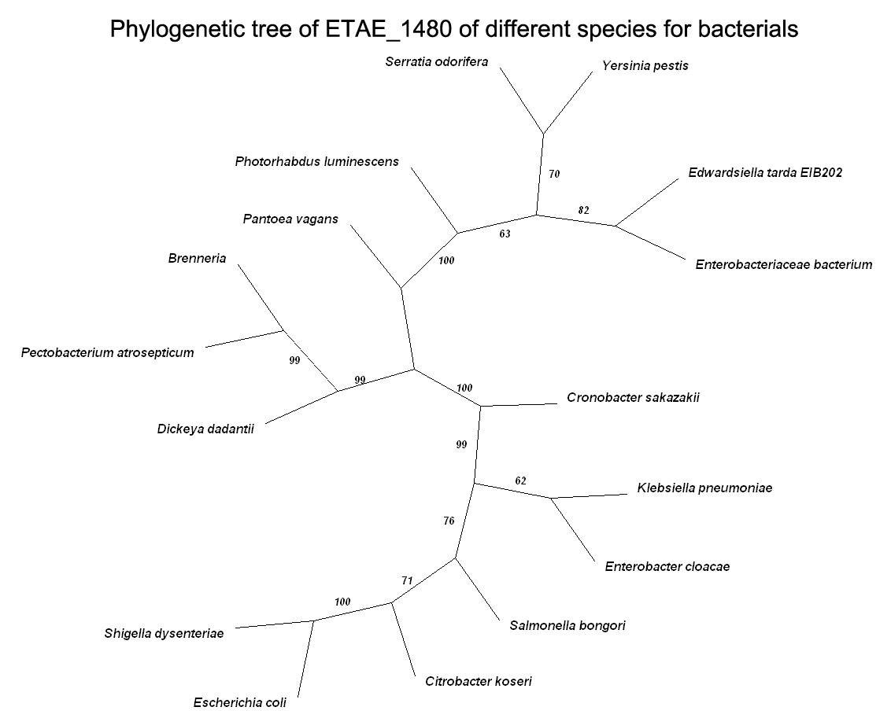

Fig1-5C, Phylogenetic tree of ETAE_1480 of different species of bacteria. The value of branch node stands for confidence. Equivalent 95% statistics probability if exceed 70,but it is incredible when lower than 50.

Phylogenetic analysis. Edwardsiella tarda EIB202 ETAE_1480 (YP_003295532.1) was performed a BLAST on NCBI. A multiple sequence alignment was created with the amimo acid sequences from other bacteria species using ClustalX. Unrooted phylogenetic tree was constructed based on the sequences using MEGA version 4.0, then was adjusted by TreeView to make it more readable. The sequences used in the phylogenetic tree are as follows: Edwardsiella tarda EIB202 MltA-interacting MipA family protein (YP_003295532.1), Enterobacteriaceae bacterium MltA-interacting protein MipA (ZP_07950737.1), Serratia odorifera MltA-interacting protein (ZP_06640154.1), Yersinia pestis hypothetical protein y2167 (NP_669478.1), Photorhabdus luminescens MltA-interacting protein precursor (NP_929795.1), Pantoea vagans MltA-interacting protein precursor (YP_003931192.1), Klebsiella pneumoniae mipA gene product (YP_001334857.1), Escherichia coli MltA-interacting protein MipA (ZP_07134300.1), Shigella dysenteriae MltA-interacting protein MipA (ZP_03065743.1), Dickeya dadantii scaffolding protein for murein synthesizing machinery (YP_003882944.1), Salmonella bongori outer membrane protein (YP_004730004.1), Citrobacter koseri hypothetical protein CKO_01804 (YP_001453369.1), Enterobacter cloacae unnamed protein product (YP_003942151.1), Pectobacterium atrosepticum MltA-interacting protein (YP_050442.1), Cronobacter sakazakii MltA-interacting protein (EGL72838.1), Brenneria MltA-interacting MipA family protein (ZP_09015650.1).

- ETAE_1723

Fig 1-6A, CDD of ETAE_1723 of Edwardsiella tarda EIB202 (NCBI: gi|269139072)

10 20 30 40 50 60 70 80 90 100
....|....|....|....|....|....|....|....|....|....|....|....|....|....|....|....|....|....|....|....|
Escherichia_coli --------MKITLSKRIGLLAILLPCALALSTTVHAETNKLVIE----SGDSAQSRQHAAMEKEQWNDTRNLRQKVNKRTEKEWDKADAAFENRDKCEQS
Shigella --------MKITLSKRIGLLAILLSCALALSTTVHAETNKLVIE----SGDSAQSRQHAAMEKEQWNDTRNLRQKVNKRTEKEWDKADAAFDNRDKCEQS
Enterobacter_cloacae --------MKVTFSKRLCLTAMLTLGAIAYTASASAETSKLVIE----SGDSAQSRQNASMDKEQWNDTRALRQKVNTRAEKEWDKHDAAFDSRDKCEQS
Salmonella_enterica -------MMNNTLSKRLCLTAMLTLAAVVYTTSAFAETSKLVIE----SGDSAQSRQEAAMEKEQWNDTRSLRQKVNTRAEKEWDKADAAFDNRDKCEQS
Klebsiella_pneumoniae --------MNMTLNKRWCLTAILALSAVVYTSSSYAATDRLVIE----SGDSAQSRQQASMEKEQWNDTRSLRQKVNKRAEKEWDKADVAFDAQDNCQKS
Cronobacter_sakazakii ------------MNKFLRHSLLLALLTGALSGVANAQTDKLIIE----SGDNARTRQDAAMDKEQWNDTRSLRQKVNKRTEKEWDKADVAFDAKDNCEKS
Pantoea ------------MKKMIPAVLLVLISSAAFTASAN--TNRLIIE----DGSTALGNEAARQDKEQWNDTRMLRNKVNTRVEKEFDKADRAYDTRDKCEQS
Dickeya_dadantii ----------MQKTSRHLLFSLAGLLMAGLWQPAQAATQHVIIE----NGNSALSKEAARQSSEQWNDTRNLRRKVNSRAEKEFDKVERAIDGEEKCNAS
Edwardsiella_tarda_EIB202 ------------MIPLLLLLGGIGWQSAAQAAS--CEAGSTCVFGSSGGQDNSLTKEQAREQREQWDQTRPLRSKVNTHVEKEFDKADRAIEQRERCERS
Enterobacteriaceae_bacterium MKLKKLQVVAR-WMPLAAALIMGGWQASALADS--CASGSTCVFGSSGGQDNSLTKEDARQQKEQWDDTRSLRNKVNTRVEKQFDKFDKAVDLQDACEKS
Serratia_proteamaculans MKTLSTQRLLRGMLPVAMLMLMGAWQAPALAAS--CTQGSTCVT-VDGSNSGAMSTEAARQSKQQFNDTKSLRNKVNTRVEKEFDKVDKAIDSEERCDDS
Yersinia_aldovae MKINSLPRLIRAFLPTVILMVPLAYLAPAQAQSANCTQGSTCVS-VGGSND-PMTKEQARQSQQQWDDTHLLRSKVNTRVEKSFDKFDRAVDAKDNCDRS
Photorhabdus_asymbiotica MNIHKS--LILKIISAIALAIPLLWQAPALAAT--CTSGSTCVT-VHGSGDSVLDKEAARQSKEQWDETKNLRTKVNKRAEKEFDKLDKAIDNRDACMKS
Xenorhabdus_nematophila MRIYSS--VILKSVSAIVLMLSLFWQAPAFSAS--CTSDSTCVT-ING-GETSLSKEKARQSKEEWNEQRRLRQKIDKRNEKEFDKYDVDIDNRDDCLKS
Clustal Consensus : . : * . ::::: : ** *::.: **.:** : : .: * *

110 120
....|....|....|....|....|
Escherichia_coli ANINAYWEPNTLRCLDRRTGRVITP
Shigella ANINAYWEPNTLRCLDRRTGRVITP
Enterobacter_cloacae ANLNAYWEPNTLRCLDRRTGRPLAP
Salmonella_enterica ANINAYWEPNTLRCLDRRTGRVITP
Klebsiella_pneumoniae ANVNAYWEPNTLRCLDRRTGRAINP
Cronobacter_sakazakii ANLNAYWEPNTLRCLDRRTGRVINP
Pantoea LNLNAYWEPNTLRCLDRRSGRPVAP
Dickeya_dadantii SNFNAYWEAKTSRCLDRRTGRPAMP
Edwardsiella_tarda_EIB202 LNVNAYWEPGTRRCLDRQSGRPLTP
Enterobacteriaceae_bacterium LNVNAYWEPNTQRCLDRNTGRPLNP
Serratia_proteamaculans LNVNAYWEPNTRKCLDRQTGRQINP
Yersinia_aldovae VNLNAYWEPNTERCLDRSSGRQINP
Photorhabdus_asymbiotica TNINAYWEPNTERCLDSNTGMPIRP
Xenorhabdus_nematophila ANINAYWEPDTKRCLDINTGRPIKP
Clustal Consensus *.*****. * :*** :* *
Fig 1-6B, Alignment of ETAE_1723 of different species of bacteria
*Identical;:Similar;.Normal
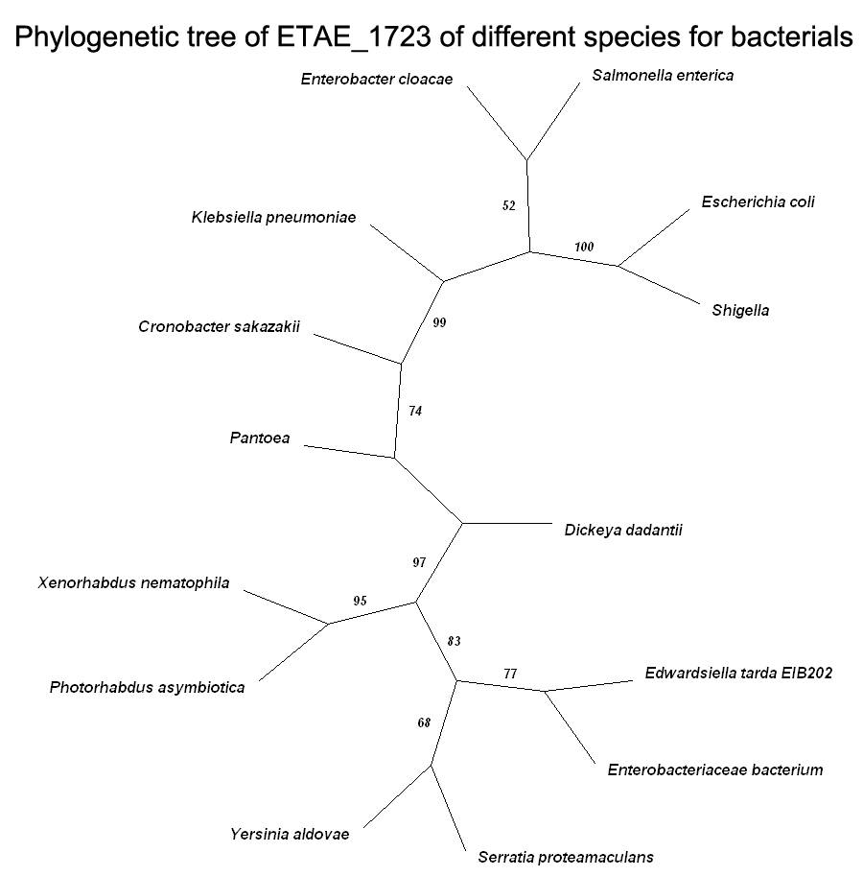

Fig1-6C, Phylogenetic tree of ETAE_1723 of different species of bacteria. The value of branch node stands for confidence. Equivalent 95% statistics probability if exceed 70,but it is incredible when lower than 50.

Phylogenetic analysis. Edwardsiella tarda EIB202 ETAE_1723 (YP_003295773.1) was performed a BLAST on NCBI. A multiple sequence alignment was created with the amimo acid sequences from other bacteria species using ClustalX. Unrooted phylogenetic tree was constructed based on the sequences using MEGA version 4.0, then was adjusted by TreeView to make it more readable. The sequences used in the phylogenetic tree are as follows: Edwardsiella tarda EIB202 hypothetical protein ETAE_1723 (YP_003295773.1), Enterobacteriaceae bacterium hypothetical protein HMPREF0864_01223 (ZP_07950459.1), Serratia proteamaculans hypothetical protein Spro_2288 (YP_001478517.1), Yersinia aldovae hypothetical protein yaldo0001_14100 (ZP_04619775.1), Photorhabdus asymbiotica hypothetical protein PAU_02185 (YP_003041021.1), Pantoea protein of unknown function DUF1283 (ZP_07377843.1), Xenorhabdus nematophila unnamed protein product (YP_003712542.1), Enterobacter cloacae unnamed protein product (YP_003941861.1), Salmonella enterica hypothetical protein SPC_2226 (YP_002637788.1), Dickeya dadantii hypothetical protein Dd703_1894 (YP_002987507.1), Escherichia coli hypothetical protein EC30301_1838 (EGW88496.1), Shigella conserved hypothetical protein (ZP_08391689.1), Klebsiella pneumoniae ynfB gene product (YP_001335245.1), Cronobacter sakazakii hypothetical protein ESA_01750 (YP_001437840.1).

- ETAE_1797
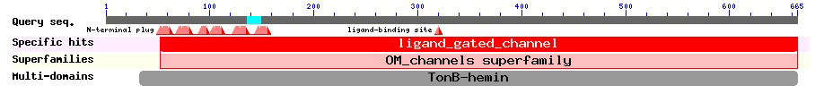

Fig 1-7A, CDD of ETAE_1797 of Edwardsiella tarda EIB202 (NCBI: gi|269139144)

10 20 30 40 50 60 70 80 90 100
....|....|....|....|....|....|....|....|....|....|....|....|....|....|....|....|....|....|....|....|
Yersinia_mollaretii MPFA------------AQAADTPTAQTAETTTAQTTAAKT--SSKKHST---DTMVVTATGNERSSFEAPMMVTVVEANTPTSETATSAADMLRNIPGLT
Serratia MPLPSYTRLRLSALSLAIACALPTVTFAQTTSTVSSSAAA--PAKTEKTGE-DAMTVVATGNQRSSFEAPMMVTVIEGNAPVSQTASTAADMLRRIPGIT
Enterobacteriaceae_bacterium ------------------MVDTPASSTSQEIAYTGNTPAG--GKDSNRQ-Q-SVMTVTATGNERDSFEAPMMVSVLENNDPETMTASSAPDMLRHIPGVT
Citrobacter_koseri ------------------MLRLQSASLRPSLLALAIVSTL--PGAAYATT--DDITVTATGNARSTFEAPMMVSVIDTSDPENQTASSAADLLRPVPGIT
Salmonella_bongori ------------------MLRLQSGFMPPSLLALAITSAF--PSAAFATT--DTLTVTATGNPRSAFEAPMMVSVIDTADPENQTAASAADLLHSVPGIT
Enterobacter_cloacae ------------------MPHLQSASLRPSLLALAIVSTL--PGVTFAAA--DEITVTATGNARSAFEAPMMVSVIDATAPENQTASSAADLLRKVPGLM
Escherichia_coli ------------------------------MLALAVSATL--PTFAFAT---ETMTVTATGNARSSFEAPMMVSVIDTSAPENQTATSATDLLRHVPGIT
Shigella_dysenteriae ------------------MSRPQFTSLRLSLLALAVSATL--PTFAFAT---ETMTVTATGNARSSFEAPMMVSVIDTSAPENQTATSATDLLRHVPGIT
Edwardsiella_tarda_EIB202 ------------------MPTLFSPALRPLTLAIGAIVLT--PSLLQAAESSDRVTVIATGNQRDSFSAPMMVTVIDQQDPVAASAASAPEMLRNVPGLS
Candidatus_Hamiltonella MSFTLPKLLRLSSLTLAISLPSLAYAESGMPDKIETEEKK--PSFNKQSLKTETITVTATGNPRDTFSTPMMITVIDRDNAKSDTASSAADILLSTPGIT
Photorhabdus_asymbiotica --------MSQSAKSTLKLSALSLAIISSIPTVYAATKS---PDSESDKSSHDVITVYATGNERDSFEAPMMVTVINNKSPQSQTAGNANDLIRKIPGIN
Xenorhabdus_bovienii --------MNPIKLPNLKLSSLSVVILTGLSSAHATTIL---AEE--NKSSKDTLTVYATGNERDSFEAPMMVTVIEGNSANNRVAGNAHDLLRNLPGIN
Proteus_mirabilis --------MSQSSR-CIKVSVL--VVATAISSAFAENKNQIYGEKNSGERNTQIITVYATGNERDSFTLPMMSTVIKNNSALTETAGSATELLRHIPGIS
Providencia_rettgeri ------------------MSVLTSAILGVIASAQAQTTEP-----TPKKNHHDVMTVYATGSERDSFETPMMVTVIKNNSPETQTASTVNDILRKVPGIG
Clustal Consensus . :.* ***. *.:* *** :*:. . * .. ::: **:

110 120 130 140 150 160 170 180 190 200
....|....|....|....|....|....|....|....|....|....|....|....|....|....|....|....|....|....|....|....|
Yersinia_mollaretii VTGSGRVNGQDVTLRGYGKNGVLTLVDGVRQGTDTGHLNSTFLDPALVKRVEVVRGPSALLYGSGALGGVIAYETVDAADLLLPGQNSGYRVYSSAATGD
Serratia VTGTGRSNGQDIMMRGYDRRGVLTLVDGIRQGTDTGHINGTFLDPGLIKRIEVVRGPSALLYGSGALGGVVAYETVDAADLLLPGRDSGFRVFGTAASGD
Enterobacteriaceae_bacterium ISGGSRANGQDISMRGYDRRGVLVLVDGVRQGTDTGHLNGTFLDPALIKRVEVVRGPGALLYGSGALGGVISYETVDAADLLMPGKNTGYRVFGTAGTQD
Citrobacter_koseri LSGSGRTNGQDISMRGYDRRGVLILVDGVRQGTDTGHLNSTFLDPALIKRIEIVRGPSALLYGSGALGGVISYETADAKDLLQEGQNSGFRVFGTGGTGD
Salmonella_bongori LSGTGRTNGQDVNLRGYDRRGVLVLVDGVRQGTDTGHLNSTFLDPALIKRVEIVRGPSALLYGSGALGGVIAYTTVDASDLLMEGQRYGFRVFGTGGTGD
Enterobacter_cloacae LDGTGRTNGQDVNLRGYDRRGVLILVDGVRQGTDTGHLNSTFLDPALIKRIEVVRGPSALLYGSGALGGVISYDTVDASDLLDAGKNSGYRVFATGATGD
Escherichia_coli LDGTGRTNGQDVNMRGYDHRGVLVLVDGVRQGTDTGHLNGTFLDPALIKRVEIVRGPSALLYGSGALGGVISYDTVDAKDLLQEGQSSGFRVFGTGGTGD
Shigella_dysenteriae LDGTGRTNGQDINMRGYDHRGVLVLVDGIRQGTDTGHLNGTFLDPALIKRVEIVRGPSALLYGSGALGGVISYDTVDAKDLLQEGQSSGFRVFGTGGTGD
Edwardsiella_tarda_EIB202 LSGVGRSNGQDITLRGYDNRGVLVLVDGVRQGTDTGHLNGTFLDPALIKRVEVVRGPGALLYGNGALGGVIAYQTVDAADLLLAGKNSGYRVFASGGTQD
Candidatus_Hamiltonella IEGVGRKNGQDVNMRGYGGKGILTLIDGVRQNLDTGHMSGHFIDPSFIKQVEIVRGPSALLYGSGALGGVISYQTVDTVDLLQPGRNSGYRVFSMGATGD
Photorhabdus_asymbiotica IAGTNRANGQDISLRGYGPQGVLTLIDGIRQGTDTGHINGTFLDPALIKQVEVVRGPSALLYGSGALGGVVAYQTVDAEDLLQAGQNHGFRVFARGATGD
Xenorhabdus_bovienii VSGSGRTNGQDISMRGYSKKGVLTLVDGIRQGTDTGHLNGLFLDPSLIKQVEVVRGPSALLYGSGALGGVIAYQTVDAADLLQEGKNTGFRVFSRAATGD
Proteus_mirabilis ISGAGRTNGETISMRGYSSNGVLTLVDGIRQGTDTGHIDSIFVDPLLIKQVEVVRGPSALLYGSGALGGVVAYDTVDASDLLAKNEHGGVRVTALGNTAQ
Providencia_rettgeri VTGTSRANGQDIYMRGFDRRGILTLVDGIRQGTDTGHVNGTFIDPALIKQVEIIRGPSALLYGSGAMGGVIAWETVDAKDLLREGQDHGFRVFTEAATGD
Clustal Consensus : * .* **: : :**:. .*:* *:**:**. ****:.. *:** ::*::*::***.*****.**:***::: *.*: *** .. * ** . : :

210 220 230 240 250 260 270 280 290 300
....|....|....|....|....|....|....|....|....|....|....|....|....|....|....|....|....|....|....|....|
Yersinia_mollaretii HSFGLGASAYGRTDDVDGILSFGTRDIGNIRQSDGFNAPNDETISNVMAKGTWRIDQIQSLSANLRYYNNSALEPKNPQ-TSAA-SSSNVMTDRTTIQRD
Serratia HSLGMGASAYGKTDNLDGLLSFGTRDVGNLRQGNGFDAPNDETINNLLAKGTWTLDENQSLSGNLRYYNNRAQEPKNPQ-EPAS-SSGNLMTDRSTIQRD
Enterobacteriaceae_bacterium HSLGMGASAYGKTDDLDGIISFSTRDRGNLRMSNGFNSPNDETISNVLTKGTWTIDENQSLSGDLRYYNNAAREPKNPQ-TENA-GTGNVMTDRSTIQRD
Citrobacter_koseri HSLGMGASAFGRTDNLDGLVAWSSRDRGDLRQGDGSTAPNDESINNMLAKGTWYINDAQALSGSLRYYNNDAQEPKNPQ-TIDA-STSNPLVDRSTIQRD
Salmonella_bongori HSLGMGASAFGRTDNLDGLLSWSSRDRGDLRQGDGSTAPNDESINNMLAKGTWKIDEAQALSGSLRYYNNAAQEPKNPQ-DLAANSVSNPMTDRSTIQRD
Enterobacter_cloacae HSIGMGASAYGRTDTLDGLVSWSSRDRGDIRQSDGARAPNDESINNMLAKGSWKIDPAQTLSGSLRYYNNDAQEPKNPQ-TTDA-SSSNPMTDRSTIQRD
Escherichia_coli HSLGLGASAFGRTENLDGIVAWSSRDRGDLRQSNGETAPNDESINNMLAKGTWQIDSAQSLSGLVRYYNNDAREPKNPQ-TVEASDSSNPMVDRSTIQRD
Shigella_dysenteriae HSLGLGASAFGRTENLDGIVAWSSRDRGDLRQSNGETAPNDESINNMLAKGTWQIDSAQSLSGLVRYYNNDAREPKNPQ-TVEASESSNPMVDRSTIQRD
Edwardsiella_tarda_EIB202 HSLGLGASAYARSDTLDGLISFSTRQRGDLRLGEGESAANRETIGNLLAKGTWLIDDAQSLRASLRYYDNAAREPKNPQ-DIQA-SANNVMTRRDTLQRD
Candidatus_Hamiltonella RSLGIGATVFGKTDDLDGLITFSVRDVGNIKESDGINAPNDEGIRNLMAKGTWKIDDSQSLSANVRYYRNNAEEILNPQ-EVNP-SLRNPMTDRKTVQKD
Photorhabdus_asymbiotica HSIGFGGATFGKTESLDGLFAFSTRDAGNIRNSNGLTADNDEFISNLIAKGSWKINENQSLSSQLRYYRNEAKQPKNPQMLIGKNEKPDSWSDRTTTQRD
Xenorhabdus_bovienii HSLGFGGAAFGKTEQLDGLFAFSSRDVGNIRYGNSLIGHNDETIGNMLAKGKWNINDSQSLSSELRYYRNQSHEPKNPQAITDNAKNDNPRADRTTTQHD
Proteus_mirabilis QSQGFGITAFGQQDNFDGLLALSARDKGTTRYGGGYRAQNDETIINLLSKGRWFIDDSNTLSGQLRYYHNNAQQPKDPQ-LANNPTPANVATNRTTTQKD
Providencia_rettgeri HSFGFGGTAFGRSDNLDGLFSFVTKETGNVRMSNGDDMKNKETIGNLLAKGTWQIDDAQKLSGQVRYYNNDANEPKNPQEINVGS--DNLKVNRTTRQRD
Clustal Consensus :* *:* :.:.: : .**:.: :: * : . . * * * *:::** * :: : * . :*** * : : :** : * * *:*

310 320 330 340 350 360 370 380 390 400
....|....|....|....|....|....|....|....|....|....|....|....|....|....|....|....|....|....|....|....|
Yersinia_mollaretii VQLKYNLKPLDQEWLNATAQVYYSEVEINARPQGTAEEGREQTTKGGKLENRTRLFTDSFASHLLTYGTEAYKQEQTPGGATESFPQADIRFGSGWLQDE
Serratia GQLSYRLKPVGQEWLDAEAKVYYSDVKINAHTNGSEDEARKQTTRGAKLENRTRLFADTFASHLFTYGSEAYKQEQTPGGATESFPQAKINFASGWLQDE
Enterobacteriaceae_bacterium AQATYKLKPVGQDWLDATLTGYTSEVKINASPTGTSYEERKQTTNGAKLENRSRLFADSFASHLLTYGTEAYKQKQTPGGATTGFPQADIKFASGWLQDE
Citrobacter_koseri MQLSYRIAPQGNDWLNADAKVYWSEARINAQNVDNTGEFRKQTTKGGKVENRTRLFSDAFASHLLTYGGEYYRQEQKPGGVTTGFPEAKIDFSSGWLQDE
Salmonella_bongori MQLTYKLAPQGNDWLNAESKVYWSEARINAQNIDNTSEYREQTTTGGKVENRTRLLTDSFASHLLTYGGEYYRQEQKPGGVTTGFPEAKIDFSSGWLQDE
Enterobacter_cloacae AQLGYRIAPAGNDWLNADAKIYWSEARINAQNIDASGEFRKQTTKGGKVENRTRLFSDSFASHLLTYGGEYYRQEQHPGGATTGFPDAKIDFSSGWLQDE
Escherichia_coli AQLSYKLAPQGNDWLNADAKIYWSEVRINAQNTGSSGEYREQITKGARLENRSTLFADSFASHLLTYGGEYYRQEQHPGGATTGFPQAKIDFSSGWLQDE
Shigella_dysenteriae AQLSYKLAPQGNDWLNADAKIYWSEVRINAQNTGSSGEYREQITKGARLENRSTLFADSFASHLLTYGGEYYRQEQHPGGATTGFPQAKIDFSSGWLQDE
Edwardsiella_tarda_EIB202 LQLEYRLKPRENTWLDASLRPYYSDVRITANPQGESAESRTQRTLGLRLENRSRLWHDGPAAHLVTYGSEAYGQSQRPGGGASAYPQADIRFASGWLQDE
Candidatus_Hamiltonella VQFSYALNPKTSDWLDAKTTLYYSDVSIDDKVKKRADQGRTQKTLGTKLENRSRLLTHSPAAHLLTYGTEFYQQKQKPEGHAKAFPDAKTNFASGWVQDE
Photorhabdus_asymbiotica AQLSYQLNPAEYDWLNAKANLYYSDITIDARTKEKGFEGRKQKTYGVKLENRSRLWTDSPLAHQFTYGGETYQQKQTPGGNTDSFPDADIRFSSGWVQDE
Xenorhabdus_bovienii AQLTYRLNPAEYNWLNTKADIYYSDVTINAKTKEKGFEGRKQETYGVKLENRSHLGANTFSVHQFTYGGEAYKQKQKPNGNTESFPDADIRFASGWVQDE
Proteus_mirabilis AQLTYQYHPSDMSWINLKTQAYYSEVDINAKTQQKGFEGREQKTYGIKIENRTQLATYPFAAHALTYGGEIYKQKQSPSANAESFPKADIRFMSGWLQDE
Providencia_rettgeri AQITYQIKPGSQEWLNFKVTPYYSDINITAKGQGTPYEGRTQKTYGIKADNRSNFYDLPLASHNLTYGSEAYKQKQTPYANTTQFPDADITFASGFLQDE
Clustal Consensus * * * *:: * *: * : * * * * : :**: : * .*** * * *.* * . : :*.*. * **::***

410 420 430 440 450 460 470 480 490 500
....|....|....|....|....|....|....|....|....|....|....|....|....|....|....|....|....|....|....|....|
Yersinia_mollaretii ITLRDLPVSILAGTRYDNYKGSSEGYADVDADKWSSRGAVSVTPTDWLMLFGSYAQAFRAPTMGEMYNDSKHFSMNIAG--NTLTNNWVPNPNLKPETNE
Serratia ITLRDLPITLLAGTRYDNYKGSSDGYADVDADKWSSRGAISITPTDWLMVFGSYSQAFRAPTMGEMYNDAKHFSIPMGP--TTITNYWVPNPNLKPETNA
Enterobacteriaceae_bacterium ITLRDLPVDIVAGTRYDNYKGSSDGYDDVNADKWSSRAAMTINPTDWLMIFGSYAQAFRAPTMGEMYNDALHFQMGPG-----MANYWKPNPNLKPETNE
Citrobacter_koseri ITLRDLPVTLLGGTRYDNYRGSSDGYDDVDADKWSSRAGLTVSPTDWLMLFGSYAQAFRAPTMGEMYNDAKHFSIGSF-----YTNYWVPNPNLRPETNE
Salmonella_bongori ITLRNLPVTLLGGTRYDNYRGSSDGYADVDADKWSSRAGMTISPTDWLMLFGSYAQAFRAPTMGEMYNDSKHFSIGRF-----YTNYWVPNPDLRPETNE
Enterobacter_cloacae ITLRDLPVTLLGGTRYDNYRGSSDGYDDVDADKWSSRAGLTVSPTDWLMLFGSYAQAFRAPTMGEMYNDSKHFSIGSF-----YTNYWVPNPNLRPETNE
Escherichia_coli ITLRDLPITLLGGTRYDSYRGSSDGYKDVDADKWSSRAGMTINPTNWLMLFGSYAQAFRAPTMGEMYNDSKHFSIGRF-----YTNYWVPNPNLRPETNE
Shigella_dysenteriae ITLRDLPITLLGGTRYDSYRGSSDGYKDVDADKWSSRAGMTINPTNWLMLFGSYAQAFRAPTMGEMYNDSKHFSIGRF-----YTNYWVPNPNLRPETNE
Edwardsiella_tarda_EIB202 ITLRDLPVSLVAGTRYDNYRAHNDSYGDINADKWSSRAAVTVTPADWLMLFTSYAQAFRAPTIGEIYNDARHFSIGPF------VNYWRPNPNLRPESNT
Candidatus_Hamiltonella ITFRDLPVSLLIGTRFDRYKAKNPKNADISADNWSSRGAVTLTPTDWLMLFASYGQAFRAPTMGEMYNDAQHFR----------GNRFKPNPNLKPEKNA
Photorhabdus_asymbiotica ITLRDLPISIIAGTRYDNYKGTNSKYKDVNADKWSSKGAISITPTDWSMLFTSYAQAFRAPTMKEMYNDSRHYPMG-----PGMNNYWIPNPNLRPESNE
Xenorhabdus_bovienii ITLRDLPVSFIVGTRYDNYNASNAKYDDISANKWSSKGAVSITPTPWSMLFTSYSQAFRAPTMGEMYNDSKHFHMPAMRGKPGFTNYWKPNPNLRPESNE
Proteus_mirabilis MTLRDVPISFIVGTRFDKYSSQNDRYDDISADKWSSKGAVSITPTDWLMLYTSYAQAFRAPTIGEMYNDAKHFDAPFP---GAPTNYWRPNPNLKPETNS
Providencia_rettgeri ISLKDLPVSFIVGTRYDHYKATSDGNEDVKKGKWSSKGAVSITPTEWSMLFASYSEAFRAPSMMEMYNDEVHFQMG------PIVNRWKPNPNLKPESTR
Clustal Consensus ::::::*: :: ***:* * . . *:. .:***:..:::.*: * *:: **.:*****:: *:*** *: * : ***:*:**..

510 520 530 540 550 560 570 580 590 600
....|....|....|....|....|....|....|....|....|....|....|....|....|....|....|....|....|....|....|....|
Yersinia_mollaretii TQEYGFGLRFSDLMMEEDELQFKTSYFDTKAKNYITTGVTMDFGFGPGGL------YCKTCSTYSTNIDRAKIWGWDATLSYQTQWFNLGLAYNRTRGKN
Serratia TQEYGFGLRFDDLLLADDSLQFKASYFDTKARDYITTDVTMELGRGPRGP------YCISCTTFSTNIDRAKIWGWDAMLSYKTAIFGWDLAYNRTRGKN
Enterobacteriaceae_bacterium TQEVGFGLRFDDVLMANDSLKFKSSYFGTKAKDYIKTQVTMDMGFVNGRF------GCIDCSTTSTNIDRAKIWGWDAAMEYQTDWFDWSLAYNRTRGKD
Citrobacter_koseri TQEYGFGLRFDNLMLSNDALEFKASYFDTKAKDYISTTVDFAAA-----------------TTMSYNVPNAKIWGWDVMTKYTADLFSLDVAYNRTRGKD
Salmonella_bongori TQEYGIGLRFDNLMLADDALEFKASYFDTNAKDYISTTVDFAAR-----------------TTMSYNVPNAKIWGWDVMTKYTADLFSLDMAYNRTRGKN
Enterobacter_cloacae TQEFGFGLRFDDLLLANDALEFKASYFDTKAKDYISTTVDFAAA-----------------TTMSYNVPNAKIWGWDMMATYATSLFNLDVAYNRTRGKD
Escherichia_coli TQEYGFGLRFDDLMLSNDALEFKASYFDTKAKDYISTTVDFAAA-----------------TTMSYNVPNAKIWGWDVMTKYTTDLFSLDVAYNRTRGKD
Shigella_dysenteriae TQEYGFGLRFDDLMLSNDALEFKASYFDTKAKDYISTTVDFAAA-----------------TTMSYNVPNAKIWGWDVMTKYTTDLFSLDVAYNRTRGKD
Edwardsiella_tarda_EIB202 TQEAGFGLRFDDLLAEGDSLQFKSSYFGTRAKNYIDTQVVNDFAKR-------------QFYTTSINVDDVKLWGWDVALNYRSDRFSWESAYNRTRGKN
Candidatus_Hamiltonella TQEYGFGVKFDDLVLTEDSVEFKASYFSTQATDYITTEVNFRKG-----------------TTQYVNVPDTNIWGWDAVLNYKTPWFGWNLAYNRTHGKN
Photorhabdus_asymbiotica TWESGFGLRFDNLLAENDELKFKASYFDTKAKDYIKLELTNPLKTKSGEIVKSRSGDPIYLNTTSTNVPSAKIWGWDISMNYESSLFSWELAYNRTEGKD
Xenorhabdus_bovienii TLESGFGLRFDDLFSSNDELKFKVSYFDTQAKDYITSIVTMPDMR----------------STTSINIPKTKIWGWDASMSYESNWFSWNLAYNRTMGKN
Proteus_mirabilis TTEYGFGFQFDDLLSNNDNLKIKAAHFNTRAKDYIDTDVAIFQGY-----------------TQSTNIPRATIWGWDIEMNYQSKFFSWDLAYNHTKGKD
Providencia_rettgeri TAEYGFGLRFDDLLMERDNLQFKASYFDTKAKDYINTYVTTPDFR-----------NPQNNYTTSINTKRAKIWGWDASMDYKTDYFNWSLAYNHTEGKD
Clustal Consensus * * *:*.:*.::. * :::* ::*.*.* :** : * * ..:**** * : *. ***:* **:

610 620 630 640 650 660 670 680 690 700
....|....|....|....|....|....|....|....|....|....|....|....|....|....|....|....|....|....|....|....|
Yersinia_mollaretii ENTNEWLDTINPDTVTSTLDVPVANSGFAVGWIGTFADRSSRVSS-----------SGSPQAGYGVNDFYVSYKGQEQLKGVTTTVMLGNAFDKEYYAPQ
Serratia EASGDWLSSINPDTVTSTLDIPLGETGLSTGWVATFAERATRVET-----------GTTEQGGYGVNDFYLSYKGRERLQGVTTTVVLGNAFDKEYYSPQ
Enterobacteriaceae_bacterium QKTGEWLDNINPDTVTSQVNVPISTTGFSVGWVGTFADRNNQVNA-----------GTAPQAGYGVNDFYVSYKGKDSFNGMTTSVVLGNAFDKEYYSSQ
Citrobacter_koseri KDTGEYISSINPDTVTSKLNIPVAQSGFSVGWVGTFADRSTHISS-----------EYSKQPGYAVNDFYVSYQGQQALKGMTTTLVLGNAFDKEYWSPQ
Salmonella_bongori MDTGEYISSINPDTVTSKLNIPLAHSGFSVGWIATFADRSTHVSS-----------QYTKQPGYAVNDFYISYQGQQALKGMTTTLVLGNAFDKAYWSPQ
Enterobacter_cloacae TDTGEYISSINPDTVTSKLDIPVAQSGFSVGWIGTFVERSTHISS-----------SYSEQPGYAVNDFYVSYKGQQQFKGITTTLVLGNAFDKAYWSPQ
Escherichia_coli TDTGEYISSINPDTVTSTLNIPIAHSGFSVGWVGTFADRSTHISS-----------SYSKQPGYGVNDFYVSYQGQQALKGMTTTLVLGNAFDKEYWSPQ
Shigella_dysenteriae TDTGEYISSINPDTVTSTLNIPIAHSGFSVGWVGTFADRSTHISS-----------SYSKQPGYGVNDFYVSYQGQQALKGMTTTLVLGNAFDKEYWSPQ
Edwardsiella_tarda_EIB202 SQSGDWIANGTPDTLSNRLDIPLAHSGFSVGWVGTFAAAFHTNDS-----------RTQPQAGYGVNDFYVSYRTPALGNQFSATTVLSNAFDKAYYAPN
Candidatus_Hamiltonella EKTGLYISSINPDTLTSSLDIPIPKKDLSAGWVMTLAESTDFMKSP----GTTHSQEIKAQPGYAVHDFYLSYKGQNQFQGVTTNLVLANAFDKEYYSPQ
Photorhabdus_asymbiotica EKSGYSLNNLSPDTITSILDIPIAQTGFSVGWISQFTNHTDFK----GKDDKGNDLK--QQAGYGINDFYVSYQGEGMLKGVTTTAVLGNAFDKEYYSPQ
Xenorhabdus_bovienii EETGESIADLSPDTLSSMLDIPLSNTGFSLGWIGKFTQHTQFRGINGDKNERGQKLS--QYAGYGINDFYVSYHGDGKLKGLTTSVVLGNAFDKEYYSPL
Proteus_mirabilis NASNASITSIEPDTLTSRLDIPVPNSDFSVGWVGQFTKKTDFT-----KHDRFNRPTNRQQAGYGVNDFYLRYEGSASLTGLTTSLVLGNAFDKKYYSSA
Providencia_rettgeri ESNGKSITSIKPDSVTSNLAVPIADSGFSVGWLGEFTRHTEFN--------KASKAE--QQAGYAVHDFYVSYQGEGQLKGLGTSVVLGNAFDKEYYSSQ
Clustal Consensus .. : **:::. : :*: ..:: **: :. **.::***: *. . :. :*.***** *::.

710
....|....|....|..
Yersinia_mollaretii GVPQDGRNAKLFVSYQW
Serratia GIPQDGRNAKLLVSYQW
Enterobacteriaceae_bacterium GVIQDGINGKLLVSYQW
Citrobacter_koseri GIPQDGRNGKIFVSYQW
Salmonella_bongori GIPQDGRNGKIFVSYQW
Enterobacter_cloacae GIPQDGRNGKIFVSYQW
Escherichia_coli GIPQDGRNGKIFVSYQW
Shigella_dysenteriae GIPQDGRNGKIFVSYQW
Edwardsiella_tarda_EIB202 GALQDGRGARLLLSYQW
Candidatus_Hamiltonella GVPQLGRTAKLLISYQW
Photorhabdus_asymbiotica GVPQDGRNAKLLVSYQW
Xenorhabdus_bovienii GAPQDGRNGKLFISYQW
Proteus_mirabilis GIPQEGRNAKVLVSYQW
Providencia_rettgeri GIPQDGRNAKLLVSFQW
Clustal Consensus * * * .::::*:**
Fig 1-7B, Alignment of ETAE_1797 of different species of bacteria
*Identical;:Similar;.Normal
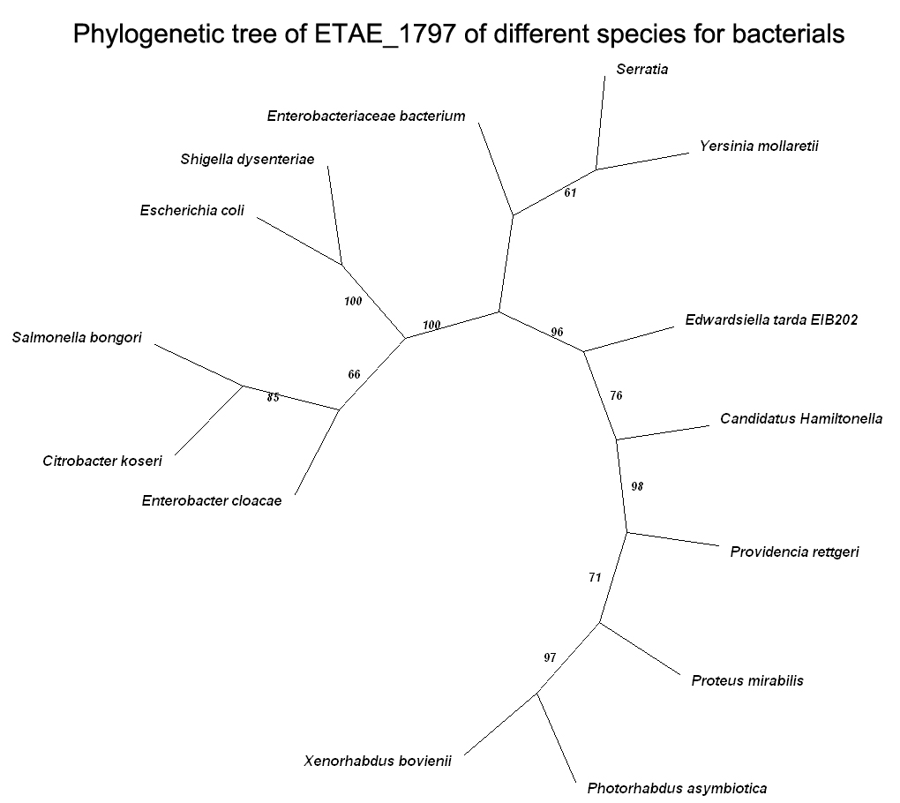

Fig1-7C, Phylogenetic tree of ETAE_1797 of different species of bacteria. The value of branch node stands for confidence. Equivalent 95% statistics probability if exceed 70,but it is incredible when lower than 50.

Phylogenetic analysis. Edwardsiella tarda EIB202 ETAE_1797 (YP_003295845.1) was performed a BLAST on NCBI. A multiple sequence alignment was created with the amimo acid sequences from other bacteria species using ClustalX. Unrooted phylogenetic tree was constructed based on the sequences using MEGA version 4.0, then was adjusted by TreeView to make it more readable. The sequences used in the phylogenetic tree are as follows: Edwardsiella tarda EIB202 hemin receptor precursor (YP_003295845.1), Enterobacteriaceae bacterium TonB-dependent heme/hemoglobin receptor family protein (ZP_07950389.1), Yersinia mollaretii Hemin receptor (ZP_04639610.1), Citrobacter koseri hypothetical protein CKO_03739 (YP_001455251.1), Enterobacter cloacae TonB-dependent heme/hemoglobin receptor family protein/TonB-dependent hemoglobin/transferrin/lactoferrin receptor family protein (CBK85185.1), Serratia TonB-dependent heme/hemoglobin receptor family protein (YP_004500545.1), Escherichia coli outer membrane heme/hemoglobin receptor (NP_756170.1), Shigella dysenteriae shuA gene product (YP_405019.1), Salmonella bongori hemin receptor protein (YP_004732540.1), Photorhabdus asymbiotica outer membrane heme/hemoglobin receptor (YP_003040735.1), Xenorhabdus bovienii hemin receptor (YP_003468403.1), Providencia rettgeri hemin receptor (ZP_06574075.1), Candidatus Hamiltonella TonB-dependent hemin receptor (YP_002924842.1), Proteus mirabilis hemin receptor (YP_002151157.1).

